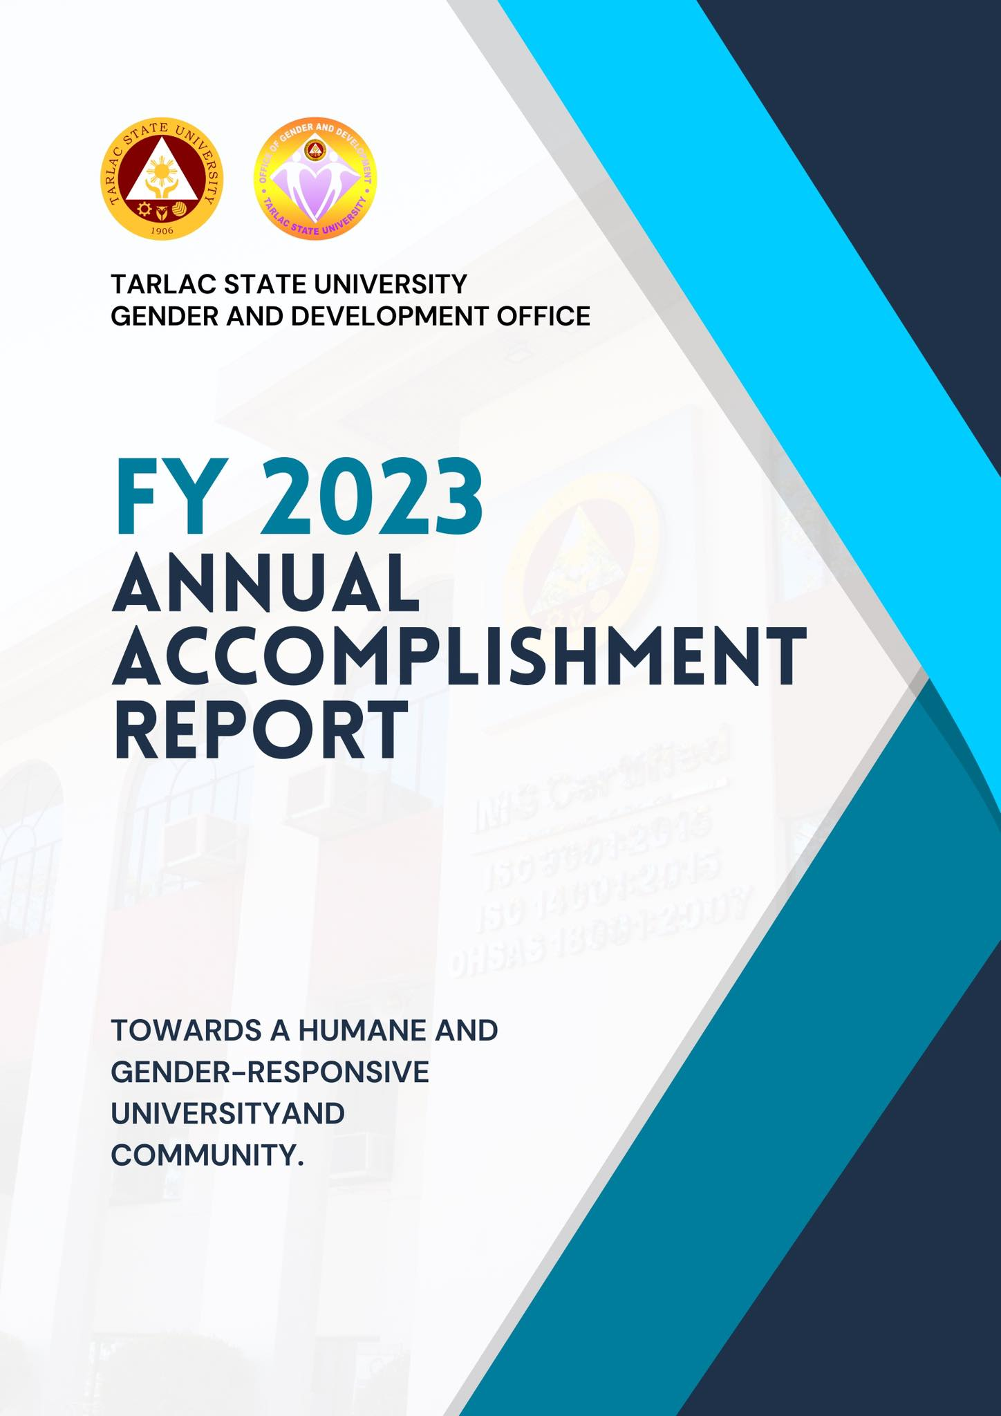

SUMMARY OF ACTIVITIES FOR 2023

Roadmap A – Resource Management Development Plan
A.1 Infrastructure, Facilities, and Equipment Development

KEY RESULT AREA  (ROADMAP) | DATE | ACTIVITY/VENUE | PERSONS/ OFFICE INVOLVED
Equipment Development | December 5, 2023 | Reproduction and distribution of IEC Materials on GAD Laws to Employees and Students | GAD Office

A.2 Executive, Faculty and Personnel Development

KEY RESULT AREA (ROADMAP) | DATE | ACTIVITY/ VENUE | PERSONS/ OFFICE INVOLVED
Executive Development | January 25, 2023 | Attendance to the 1st National Peace Convention at PICC, 9:00AM to 5:00PM | Dr. Rita E. Pulmano  TSU Administrative Council
 | March 16, 2023 | Attendance to the 1st Quarter Meeting of the RGADC III @ 1:00PM via Zoom | Dr. Rita E. Pulmano
 | March 28, 2023 | RGADC III Training titled “DigitALL: Innovation and Technology for Gender Equality” (2023 RGADC III National Women’s Month Celebration) @8:00AM to 5:00PM via Zoom and FB Livestreaming | Dr. Rita E. Pulmano  Ms. Jamie Contreras  Ms. Maritess Timbol  Ms. Cathy Dela Cruz  Ms. Rachel G. Ibale  Ms. Khyla Nicole R. Guevarra  Mr. Jhon Deric D. Tañedo
 | April 18, 2023 | Attended the First Quarter Meeting of GAD Focal Point System (GFPS) and Provincial Committee on Anti-Trafficking and Violence Against Women at the Bulwagan ng mga Gobernador – Capitol Building | Ms. Khyla Nicole R. Guevarra
 | May 10, 2023 | Revised OTDTC and Brand Manual Orientation | Ms. Khyla Nicole R. Guevarra
 | May 11, 2023 | GAD Technical Working Group, SSC, and CSC Representatives Meeting/ Second Quarter Meeting | Dr. Rita E. Pulmano  Ms. Khyla Nicole R. Guevarra  Mr. Jhon Deric D. Tañedo  Ms. Anna Lorraine P. Capinpin  OGAD Coordinators  SSC Representatives
 | May 19, 2023 | Project Procurement Management Plan Orientation at the TSU Main AVR | Mr. Jhon Deric D. Tañedo
 | June 21, 2023 | Attendance to the “2023 PCW GAD Webinar 3 – Towards A Gender-Responsive Agency: The 7 Steps in Formulating A GAD Agenda” via Zoom | Mr. Jhon Deric Tañedo  Ms. Khyla Nicole Guevarra  Ms. Jamie Contreras  Mr. Alfred Rigor  Ms. Merlie Espiritu
Faculty Competency Development  Faculty Competency Development | February 23, 2023 | Cavite State University “My Pulpol Love: A Webinar on Preventing Early Pregnancy” @8:00AM via Zoom and FB Livestreaming | Dr. Rita E. Pulmano  GAD Staff  Prof. Juvy V. Galamay  Ms. Maritess O. Timbol  Ms. Merlie Q. Espiritu
 | March 8, 2023 | Philippine Commission on Women’s “Breaking the Code” Event at 8:00AM to 5:00PM via Facebook Live | Dr. Rita E. Pulmano  Ms. Anna May M. Angeles  Mr. Jhon Deric Tañedo  Prof. Christine Janelle Santiago  Ms. Ronalyn Domingo  Ms. Merlie Q. Espiritu  Ms. Maritess O. Timbol  Prof. Sheila Jane L. Gonzales  GAD Staff
Personnel Competency Development  Personnel Competency Development  Personnel Competency Development  Personnel Competency Development | January 18, 2023 | GAD-HRDMO Partnership in the “Gender Sensitivity Orientation for Newly-hired Employees” via Zoom at 8:00AM to 5:00PM | Assoc. Prof. Sheila Jane L. Gonzales  Mr. Bryan Jan S. Dizon  (Speakers)  Dr. Rita E. Pulmano  Mr. Marlon C. Dela Cruz  GAD Staff  HRDMO-TOD Staff
 | January 31, 2023 | Workers’ Occupational Health and Safety Seminar at 8:00Am to 5:00PM via Zoom | Ms. Khyla Nicole R. Guevarra  Mr. Jhon Deric D. Tañedo
 | March 31, 2023 | GAD-CASS-SC partnership in “Juana Talks” and “Lakad, Juana” at TSU Main Campus | Dr. Rita E. Pulmano  Ms. Khyla Nicole R. Guevarra  Ms. Rachel G. Ibale  Mr. Jhon Deric D. Tañedo  Mr. Marc John Paul Agbuya (GAD Intern)  Ms. Ma. Aurea Navarro (GAD Intern)  CASS-SC Officers
 | June 1, 2023 | Attendance to the “Orientation for Newly Designated Document Control Coordinators” at the Engineering AVR | Ms. Anna Lorraine P. Capinpin
 | June 2, 2023 | Attendance to the “Refresher Course for previously appointed Document Control Coordinators” at the Engineering AVR | Ms. Khyla Nicole R. Guevarra
 | August 2, 2023 | GAD-HRDMO Partnership in the Gender Sensitivity Orientation for the Newly Hired Employee at AVR, Engineering Bldg. | Dr. Rita E. Pulmano  Assoc. Prof. Sheila Jane Gonzales (Speaker)  Prof. Jovy P. Tomas (Speaker)  Prof. Christine Janelle M. Santiago  Ms. Anna Lorraine P. Capinpin  Ms. Justice Faith Anne R. Aguilar  Mr. Jhon Deric D. Tañedo  HRDMO Staff
 | August 8-9, 2023 | Childcare Enrollment with a total of fifteen (15) enrolled students. | Ms. Justice Faith Anne R. Aguilar  Ms. Anna Lorraine P. Capinpin  Mr. Jhon Deric D. Tañedo
 | August 10, 2023 | Parent’s Orientation for Childcare | Dr. Rita E. Pulmano  Ms. Justice Faith Anne R. Aguilar  Ms. Anna Lorraine P. Capinpin  Mr. Jhon Deric D. Tañedo
 | August 11, 2023 | Worker’s Occupational Health and Safety Seminar via Zoom | Ms. Justice Faith Anne R. Aguilar  Ms. Anna Lorraine P. Capinpin  Mr. Jhon Deric D. Tañedo
 | September 7, 2023 | GMMS TRAINING 2023 at PCW Conference Room, Malacañang Palace Complex, San Miguel, Manila. 8AM-5PM | Dr. Rita E. Pulmano  Ms. Anna Lorraine P. Capinpin  Ms. Christina C. Ibe
 | September 15, 2023 | Childcare Meeting with Parents/Guardians concerning emergency protocol via MS Teams. | Dr. Rita E. Pulmano  Ms. Justice Faith Anne R. Aguilar  Ms. Christina C. Ibe  Ms. Anna Lorraine P. Capinpin  Mr. Jhon Deric D. Tañedo
 | September 19, 2023 | PCW Webinar on the preparation of GAD Plan and Budget for the fiscal year 2024, via Zoom at 8AM to 5PM. | Dr. Rita E. Pulmano  Ms. Christina C. Ibe  Engr. Raymond P. Tiamzon
 | November 9 & 10, 2023 | OGAD Strategic Planning with the theme “TSU Goal-oriented, Agenda-packed, Development-driven (GAD) 2023” held at Baguio City. | Dr. Rita E. Pulmano  Dr. Grace N. Rosete  Prof. Sheila Jane L. Gonzales  Prof. Christine Janelle M. Santiago  Prof. Jovy P. Tomas  Ms. Justice Faith Anne R. Aguilar  Ms. Christina C. Ibe  Ms. Anna Lorraine P. Capinpin  Mr. Jhon Deric D. Tañedo  GAD Coordinators
 | November 20-22, 2023 | OVPA Strategic Planning Workshop and Teambuilding held at San Juan, La Union | Dr. Rita E. Pulmano  Dr. Grace N. Rosete  OVPA Staff
 | November 23, 2023 | Childcare Unit Celebrates the National Children’s Month with the theme “Building Pathways of Healthy Foundation for Every Filipino Child and Family” held at AVR Business Center | Dr. Rita E. Pulmano  Dr. Grace C. Hasegawa  Guest Speaker  Prof. Jovy P. Tomas  Ms. Justice Faith Anne R. Aguilar  Prof. Sheila Jane L. Gonzales  Prof. Christine Janelle M. Santiago  Ms. Christina C. Ibe  Ms. Anna Lorraine P. Capinpin  Mr. Jhon Deric D. Tañedo  GAD Coordinators
 | December 1, 2023 | GAD Director, Unit Heads, Staff and Student Leader’s Meeting for the preparation of 18-DAY Campaign to END VAW and seminars for “Babae Ka and Bawal Bastos Seminar” | GAD Office  SSC Leaders
 | December 1, 2023 | Attended a seminar on Workplace Mental Health Program facilitated by the HRDMO. | GAD Staff  HRDMO Staff
 | December 14-15, 2023 | TSU-OGAD conducted a 2-day webinar for the TSU Non-Teaching employees titled “Strengthening the Integration of GAD Mechanisms in the Workplace for a VAW Free TSU” | GAD Office  TSU Non-Teaching Employees
 | December 19-20, 2023 | TSU-OGAD conducted a 2-day webinar for the TSU Faculty Personnel titled “Strengthening the Integration of GAD Mechanisms in the Workplace for a VAW Free TSU” | Dr. Rita E. Pulmano  Prof. Sheila Jane L. Gonzales  Prof. Christine Janelle M. Santiago  Prof. Jovy P. Tomas  Ms. Justice Faith Anne R. Aguilar  Ms. Christina C. Ibe  Ms. Anna Lorraine P. Capinpin  Mr. Jhon Deric D. Tañedo  TSU Faculty Personnel
 | December 19-20, 2023 | TSU-OGAD conducted a 2-day webinar for the TSU Admin Council/Members of the Board titled “Enhancing GAD Mainstreaming Towards a More Responsive Leadership and Governance” | Dr. Rita E. Pulmano  Prof. Sheila Jane L. Gonzales  Prof. Christine Janelle M. Santiago  Prof. Jovy P. Tomas  Ms. Justice Faith Anne R. Aguilar  Ms. Christina C. Ibe  Ms. Anna Lorraine P. Capinpin  Mr. Jhon Deric D. Tañedo  TSU Admin Council and Members of the Board.

Roadmap B – Instructional Quality and Relevance Development Plan

KEY RESULT AREA (ROADMAP) | DATE | ACTIVITY/ VENUE | PERSONS/ OFFICE INVOLVED
Student Support Services Development  Student Support Services Development  Student Support Services Development  Student Support Services Development  Student Support Services Development  Student Support Services Development  Student Support Services Development  Student Support Services Development | January 13, 2023 | GAD-CJEPS Partnership in the “Work Ethics and Safe Spaces Act Webinar” via Zoom at 1:00PM to 5:00PM | Atty. Jansen San Juan  Ms. Czarina C. Custodio  (Speakers)  Ms. Rachel G. Ibale  CBA-SC Officers
 | February 14, 2023 | GAD-COS-Red Cross Youth Council’s Partnership in the “Mass Blood Letting Activity: ‘You are Somenone’s Type’ at TSU Lucinda Campus | GAD Staff  GAD Student Interns  COS Red Cross Youth Council
 | February 20, 2023 | GAD-CTED’s Partnership in the webinar titled “Living with ADHD” from 1:00 PM to 4:00 PM | Dr. Joanne Marie I. Escalona  (Speaker)  Ms. Rachel G. Ibale  CTED-Guild of Elementary Educators Officers
 | February 27, 2023 | GAD-CTED-STO’s Partnership in the webinar titled “Child Protection & Safe Spaces Webinar” from 8:00AM to 12NN via MS Teams | Atty. Jewel Dela Cruz  (Speaker)  Dr. Rita E. Pulmano  Ms. Khyla Nicole R. Guevarra  CTED-Student Teachers’ Organization Officers
 | March 10, 2023 | GAD-CEJPS’ Partnership in the “Work Ethics and Safe Spaces” Webinar at 1:00PM to 5:00Pm via Zoom | Atty. Hendrix Bongalon (Speaker)  Ms. Mari Jose (Speaker)  Dr. Rita E. Pulmano  Dr. Niña Garcia  Ms. Rachel G. Ibale  Ms. Khyla Nicole R. Guevarra  Mr. Jhon Deric D. Tañedo  Ms. Adina Acuin  GAD Interns
 | March 13, 2023 | GAD-COS-RCYC-COSSC’s Partnership in “Bend the Curve: Empowering through HIV Awareness” at 8:00AM via Zoom | Dr. Rommel Hernandez (speaker)  Mr. Brian Von Dayrit (speaker)  Dr. Rita E. Pulmano  Ms. Merlie Espiritu  Ms. Rachel G. Ibale  COS-RCYC Officers  COS Student Council Officers
 | March 17, 2023 | GAD-SSC Partnership in “Mx. Warrior 2023” at 6:00PM at TSU Main Gymnasium | Dr. Rita E. Pulmano  SSC President John Cedric Malicdem  Ms. Rachel G. Ibale  Ms. Khyla Nicole R. Guevarra  Mr. Jhon Deric D. Tañedo  SSC Officers
 | March 20, 2023 | GAD-CTED-GEMs Partnership in “Promoting Gender Empowerment through Education: Understanding Canon of Values and Principles” at 10:00AM via MS Teams | Mr. Jon-Ville Caliboso  (speaker)  Ms. Rachel G. Ibale  GEMs Officers
 | March 20, 2023 | GAD-COESSE-TSU Psychological Society Partnership in “The Women’s Month Celebration Psy-Competition” | Dr. Rita E. Pulmano  Ms. Khyla Nicole R. Guevarra  COESSE-TSU Psychological Society Officers
 | March 23, 2023 | GAD-CEJPS-Guidance and Counselling Unit Partnership in “Work Ethics and Safe Spaces Act” Seminar for TSU – Laboratory School @ 8:00AM at Student Center Building, TSU Lucinda Campus | Atty. Jewel Dela Cruz  Ms. Jo Marie Brun-Osongco  (speakers)  Dr. Rita E. Pulmano  Dr. Niña C. Garcia  Ms. Khyla Nicole R. Guevarra  Ms. Rachel G. Ibale  Mr. Jhon Deric D. Tañedo  GAD Interns  CEJPS Interns  Guidance and Counselling Interns
 | April 22, 2023 | OGAD-CTE Partnership in the “Gender Responsive Advocacy: How Civil Society is Changing the Landscape of Education” | Dr. Rita E. Pulmano  Dr. Krizna Rei Places (Speaker)  Ms. Khyla Nicole R. Guevara  Mr. Jhon Deric D. Tañedo  Ms. Jovy P. Tomas  TSU - Maharlika
 | April 29, 2023 | OGAD-NSTP-LTS Partnership in the “Gender-Responsive Literacy Training Services Seminar Series” at the TSU – Alumni Center and Student Center - AVR | Dr. Rita E. Pulmano  Prof. Mary Jane Rigor (Speaker)  Ms. Regie Jimenez (Speaker)  Mr. Leslie Querimit (Speaker)  Ms. Khyla Nicole R. Guevara  Mr. Jhon Deric D. Tañedo  NSTP Coordinators
 | May 5, 2023 | K1NAIYA: Rekindling the Blaze through Fostering Gender Inclusive Leadership at the TSU – Villa Lucinda Campus | Dr. Rita E. Pulmano  Ms. Khyla Nicole R. Guevarra  Mr. Jhon Deric D. Tañedo  CASS Student Council Officers  CASS Student Leaders
 | May 6, 2023 | Gender-Responsive Literacy Training Service Seminar Series Day 2 at the TSU Gymnasium | Dr. Rita E. Pulmano  Ms. Khyla Nicole R. Guevarra  Mr. Jhon Deric D. Tañedo  NSTP Office
 | May 18-19, 2023 | Saliksiklaban 3: University-Wide Undergraduate Research Competition at the CCS AVR  - ABLESS  - GAD Researches  STEM | Dr. Rita E. Pulmano  Ms. Khyla Nicole R. Guevarra  Mr. Jhon Deric D. Tañedo  OTDTC Staff  OURD Staff
 | May 30, 2023 | 7th Annual Trailblaze Leadership Congress  Alab: Makabagong Pagpapanday  Villa Lucinda Campus - TSU Hotel | Dr. Rita E. Pulmano (Speaker)  Ms. Khyla Nicole R. Guevara  Mr. Jhon Deric D. Tañedo  Ms. Anna Lorraine P. Capinpin  SSC and CSC Officers
 | July 07, 2023 | GAD-CEJPS Partnership in the seminar titled “Work Ethics and Safe Spaces Act (WESSA) from 8:00AM to 12NN at Lucinda Campus – TSU Hostel | Atty. Hendrix Bongalon (Speaker)  Prof. Czarina C. Aguilar (Speaker)  Assoc. Prof. Sheila Jane Gonzales  Dr. Niña Garcia  Ms. Anna Lorraine P. Capinpin  Mr. Jhon Deric D. Tañedo  Ms. Justice Faith Anne R. Aguilar
 | September 2, 2023 | TSU-OGAD with JPIA for the preparation of the students in their On-the-Job Training and Research Orientation including the Safe Spaces Act with Professor Winifredo L. Luis as the resource speaker. | Dr. Rita E. Pulmano  Prof. Winifredo L. Luis  Ms. Anna Lorraine P. Capinpin  Ms. Christina C. Ibe  Ms. Justice Faith Anne R. Aguilar  Mr. Jhon Deric D. Tañedo  HRDMO Staff
 | September 12, 2023 | GAD Office in partnership with CEJPS and CPAG on webinar titled “Work Ethics and Safe Spaces Act” via Zoom Meeting and Facebook Live with Prof. Winifredo Luis and Ms. Jo Marie Osongco as the resource speaker. | Dr. Rita E. Pulmano  Dr. Niña G. Valentin  Prof. Winifredo L. Luis  Ms. Jo Marie Osongco  Ms. Anna Lorraine P. Capinpin  Ms. Christina C. Ibe  Mr. Jhon Deric D. Tañedo  CPAG Students  CEJPS Staff
 | September 16, 2023 | TSU-OGAD with CBA Student Council held a “Gender Sensitivity Orientation” via Zoom with Mr. Bryan Jan S. Dizon as the resource speaker. | Dr. Rita E. Pulmano  Mr. Bryan S. Dizon  CBA Students  Ms. Justice Faith Anne R. Aguilar  Ms. Christina C. Ibe  Ms. Anna Lorraine P. Capinpin  Mr. Jhon Deric D. Tañedo
 | September 18, 2023 | Breaking TSUians Career Ceiling through Gender Mainstream and Labor Education at Tarlac State University Gymnasium 8AM – 12PM | Dr. Rita E. Pulmano  Dr. Niña G. Valentin  Ms. Anna Lorraine P. Capinpin  Ms. Christina C. Ibe  Ms. Justice Faith Anne R. Aguilar  Mr. Jhon Deric D. Tañedo  CEJPS Staff
 | September 22, 2023 | TSU-OGAD and COS-PAFT held a Leadership Training and Gender Sensitivity and Pressure and Stress Management Seminar with Dr. Rita E. Pulmano as a resource speaker, held at Student Center Function Hall, 3rd Flr. Lucinda Campus. | Dr. Rita E. Pulmano  Ms. Justice Faith Anne R. Aguilar  Ms. Christina C. Ibe  Ms. Anna Lorraine P. Capinpin  Mr. Jhon Deric D. Tañedo
 | October 9, 2023 | TSU-OGAD with UAPSA conducted a seminar titled “Metamorphosis: Understanding the Safe Spaces Act in fostering inclusive and safe spaces for LGBTQI+ community (Architectural Design Kick-off)”. 1PM-5PM via Facebook Live. | Dr. Rita E. Pulmano  Prof. Winifredo L. Luis  Resource Speaker  Ms. Anna Lorraine P. Capinpin  Ms. Christina C. Ibe  Ms. Justice Faith Anne R. Aguilar  Mr. Jhon Deric D. Tañedo  HRDMO Staff
 | October 9, 2023 | GAD Office in partnership with JPSPA in Debate Workshop titled “Of Strength Through Speech: The Unique Symbiotic Relationship of Empowerment and Debate”, 9am- 12nn at College of Engineering AVR, Main Campus. | Dr. Rita E. Pulmano  Mr. Eowyn Charles Bueno  Resource Speaker  Ms. Anna Lorraine P. Capinpin  Ms. Christina C. Ibe  Mr. Jhon Deric D. Tañedo  Ms. Justice Faith Anne R. Aguilar  JPSPA Students Staff
 | October 18, 2023 | OGAD with Federation of Red Cross Youth Council (FRCYC) and the Nursing Arts Club conducted a seminar, “The Power of Knowledge: Guiding Youth Towards Informed Choices in Relationships and Sexual Health” 8AM-12NN at AB Center Wing AVR, Lucinda Campus. | Dr. Rita E. Pulmano  Mr. Elice Jude T. Rosete  Resource Speaker  Ms. Jasmin Joy Dizon  Resource Speaker  Ms. Anna Lorraine P. Capinpin  Ms. Christina C. Ibe  Mr. Jhon Deric D. Tañedo  Ms. Justice Faith Anne R. Aguilar  FRCYC Students Staff
 | October 18, 2023 | Supreme Student Council in partnership with OGAD for conducting an activity in line with the celebration of 117th Foundation Week, the MR. & MS. TSU 2023 from 6PM – 12AM at the TSU Main Campus Gymnasium. | Dr. Rita E. Pulmano  Prof. Sheila Jane L. Gonzales  Ms. Anna Lorraine P. Capinpin  Ms. Christina C. Ibe  Ms. Justice Faith Anne R. Aguilar  Mr. Jhon Deric D. Tañedo  SSC Students
 | October 19, 2023 | OGAD – JPSPA Debate Competition “World War IV” held at CASS Theater Room from 9AM to 12NN | Dr. Rita E. Pulmano  Ms. Anna Lorraine P. Capinpin  Ms. Christina C. Ibe  Mr. Jhon Deric D. Tañedo  Ms. Justice Faith Anne R. Aguilar  JPSPA Student Staff
 | October 26, 2023 | OGAD – COESSE “Mindfulness Day 2023: Embracing the Present Moment”  held at TSU Main Campus, Gymnasium from 8AM to 12NN | Dr. Rita E. Pulmano  Ms. Anna Lorraine P. Capinpin  Ms. Christina C. Ibe  Ms. Justice Faith Anne R. Aguilar  COESSE Student Staff
 | December 2, 2023 | OGAD with CBA Student Council conducted a webinar entitled “Titindig Ako Kasama Mo” via Zoom from 8-12nn | GAD Office  CBA Student Council
 | December 2, 2023 | OGAD with JFINEX conducted a webinar on “Yakap, You’re more than enough” via Zoom from 1-5PM | GAD Office  JFINEX Members

Roadmap C – Research and Community Service Development
C.1 Research Development

KEY RESULT AREA (ROADMAP) | DATE | ACTIVITY/ VENUE | PERSONS/ OFFICE INVOLVED
Research Publication and Presentation Development Plan | April 18, 2023 | Served as an Evaluator during the First Quarter Research Proposal Colloquium | Dr. Rita E. Pulmano
 | August 25, 2023 | Research Colloquium at TSU Lucinda Campus | Dr. Rita E. Pulmano  (Evaluator)

C.2 Community Extension Services Development

KEY RESULT AREA (ROADMAP) | DATE | ACTIVITY/ VENUE | PERSONS/ OFFICE INVOLVED
Community Extension Services  /  Academe Government Agencies Linkages Development | March 3, 2023 | Served as the Resource Speaker in the LGU-Gerona “Training on the Use of Gender-Responsive LGU Ka ba? (GeRL Ka Ba?) and HGDG Tool” at ABC Hall, Municipal Compound, Gerona, Tarlac | Dr. Rita E. Pulmano  Assoc. Prof. Sheila Jane Gonzales  LGU-Gerona Officials
 | March 30, 2023 | GAD-CBA Extension Office Seminar on “Gender Sensitivity Orientation, Anti-Violence against Women and their Children, and Magna Carta of Women” at Tibag Elementary School, Tarlac City | Assoc. Prof. Sheila Jane Gonzales  Assoc. Prof. Jovy Tomas  Prof. Christine Janelle Santiago  (Speakers)  Tibag Elementary School’s Parents-Teachers Association
Community Extension Services  /  Academe Government Agencies  Linkages Development | April 20, 2023 | Attended the Launching of the First Batch of Community Development Projects and Capacity Building for Project Implementers spearheaded by the OUES at the TSU -Alumni Center | Dr. Rita E. Pulmano
 | June 14, 2023 | Served as the Resource Speaker in the Municipal Social Welfare and Development Office – Capas activity entitled “Gender and Development Orientation for the Barangay Healthcare Workers of Capas, Tarlac” | Dr. Rita E. Pulmano  Ms. Rosita Ferrer  Office of the University Extension Services
 | July 19-21, 2023 | Screening, Brief Intervention and Referral to Treatment (SBIRT) for Providers Training at Student Center Function Hall, Lucinda Extension Campus | Assoc. Prof. Sheila Jane Gonzales
 | July 20-21, 2023 | Training on RA 9184 or Philippine Government Procurement Reform Act | Assoc. Prof. Sheila Jane Gonzales  Prof. Jovy Tomas  Prof. Christine Jannelle Santiago
 | July 25-28, 2023 | Community-Based Drug Rehabilitation (CBDR) for Facilitators Training | Assoc. Prof. Sheila Jane Gonzales
Community Extension Services  /  Academe Government Agencies Linkages Development | September 12-13, 2023 | Dr. Rita E. Pulmano with Mr. Oliver Cura as a Resource Speaker on HGDG Parole and Probation Seminar & Stress and Pressure Management in line with the celebration of 123rd Philippine Civil Service Anniversary held at Subic. | Dr. Rita E. Pulmano  Mr. Oliver Cura
 | October 17, 2023 | Served as a resource speaker in a seminar entitled “Mainstreaming of Gender and Development Perspectives in the Development and Enhancement of Long-Term Livelihood Projects in the Municipality of Pura | Prof. Christine Janelle M. Santiago  Prof. Sheila Jane L. Gonzales
 | December 13, 2023 | TSU-OGAD meeting with the Central Azucarera de Tarlac High School regarding partnership and extension services. | Dr. Rita E. Pulmano  Prof. Sheila Jane L. Gonzales  Prof. Christine Janelle M. Santiago  Prof. Jovy P. Tomas  Ms. Justice Faith Anne R. Aguilar  Ms. Christina C. Ibe  Ms. Anna Lorraine P. Capinpin  Mr. Jhon Deric D. Tañedo  CATHS-GAD GFPS

C.4 Gender and Development
Annual Campaign/Celebration

KEY RESULT AREA (ROADMAP) | DATE | ACTIVITY/ VENUE | PERSONS/ OFFICE INVOLVED
Annual Campaign/  Celebration | March 7, 2023 | 2023 National Women’s Month Celebration Kick-Off Program @ TSU Main | Dr. Rita E. Pulmano  GAD Coordinators  GAD Staff
 | December 5, 2023 | TSU-OGAD 18-DAY Campaign to End VAW Flag Raising Ceremony and Kick-Off Activity | Dr. Rita E. Pulmano  Unit Heads  GAD Coordinators  Student Leaders

Roadmap: D – Institutional Quality Assurance Development Plan
D.3 Quality Management System Development

KEY RESULT AREA (ROADMAP) | DATE | ACTIVITY/ VENUE | PERSONS/ OFFICE INVOLVED
Quality Management System Development | January 24, 2023 | Submitted the Revised GAD Plan and Budget 2023 via GMMS | Dr. Rita E. Pulmano  Ms. Rachel G. Ibale
 | February 24, 2023 | Submitted the GAD Accomplishment Report 2022 via GMMS | Dr. Rita E. Pulmano  Ms. Khyla Nicole R. Guevarra
 | March 2, 2023 | PCW and CHED endorsed GAD Plan and Budget (GPB) 2023 through GMMS | GAD Office
 | June 15, 2023 | Submission of the Revised 2022 GAD Accomplishment Report to the Philippine Commission on Women via GMMS | Dr. Rita E. Pulmano  Ms. Khyla Nicole R. Guevarra

Other Accomplishments

DATE | ACTIVITY/ VENUE | PERSONS/ OFFICE INVOLVED
January 11, 2023 | Attended the Academic Council Meeting @ AVR | Dr. Rita E. Pulmano
January 19, 2023 | GAD Coordinators and Staff 1st Quarter Meeting | Dr. Rita E. Pulmano  GAD Coordinators  GAD Staff
January 27, 2023 | Attendance to the RES Directors’ Meeting at 11:30 AM | VP Murphy P. Mohammed  RES Directors
January 31, 2023 – February3, 2023 | Joined the Annual University Planning at Blue Coral Beach Resort, San Juan, Batangas | Dr. Rita E. Pulmano  TSU Administrative Council  Offices of the VPs and selected Staff
February 14, 2023 | Attendance to the Directors’ Meeting under VPRES at 11:00 AM | Dr. Murphy P. Mohammed  Dr. Rita E. Pulmano  VPRES Directors
 | Submitted the DPCR (Targets) for January to December 2023 of Dr. Rita E. Pulmano | Dr. Rita E. Pulmano  Ms. Rachel G. Ibale  Mr. Jhon Deric D. Tañedo
March 9, 2023 | Attended the Academic Council via Zoom at 9:00 AM | Dr. Rita E. Pulmano
March 9, 2023 | Attended the Administrative Council via Zoom at 9:00 AM | Dr. Rita E. Pulmano
March 30, 2023 | Attended the RES Directors’ Meeting  @9:00 AM at TSU Main AVR | Dr. Rita E. Pulmano
April 14, 2023 | Attended the Vice President for Administration Directors’ Meeting | Dr. Rita E. Pulmano
June 16, 2023 | Submission of the Revised PPMP for 2024 to the Procurement Office | Dr. Rita E. Pulmano  Mr. Jhon Deric D. Tañedo
June 21, 2023 | Review of the Updated Guidelines for the Reestablishment of the Childcare Center by Dr. Rommel Hernandez | Dr. Rita E. Pulmano  Ms. Justice Faith Anne R. Aguilar
 | Request for the Supplementary Budget for the Materials of Childcare Center | Dr. Rita E. Pulmano  Ms. Justice Faith Anne R. Aguilar
July 6, 2023 | National Public Hearing/Consultation via zoom at 9:00 AM | Assoc. Prof. Sheila Jane Gonzales
July 6, 2023 | PPMP Evaluation at SPMU Office | Assoc. Prof. Sheila Jane Gonzales  Mr. Jhon Deric D. Tañedo
July 12, 2023 | Revision of Registration Form for Childcare Center | Mr. Jhon Deric D. Tañedo  Ms. Anna Lorraine P. Capinpin  Ms. Justice Faith Anne R. Aguilar
August 11, 2023 | Blessing of Childcare Center | Dr. Rita E. Pulmano  Ms. Justice Faith Anne R. Aguilar  Ms. Anna Lorraine P. Capinpin  Mr. Jhon Deric D. Tañedo
August 22, 2023 | Submission of DPCR from January to June 2023 | Dr. Rita E. Pulmano  Ms. Anna Lorraine P. Capinpin
August 23, 2023 | Academic Council Meeting and Admin Meeting at CASS Theater Room | Dr. Rita E. Pulmano
August 24, 2023 | Preparation of New Organizational Structure and Functional Chart | Dr. Rita E. Pulmano  Christina C. Ibe  Ms. Anna Lorraine P. Capinpin  Mr. Jhon Deric D. Tañedo
August 25, 2023 | Submission of CSW FORM: Approving of the organizational structures with duties & functions of offices under the Office of Gender and Development | Dr. Rita E. Pulmano  Christina C. Ibe  Ms. Anna Lorraine P. Capinpin  Mr. Jhon Deric D. Tañedo
September 11, 2023 | Submission of GAD Survey Accomplishment Report to be submitted in Congress in preparation for budget deliberations of CHED and SUCs. | Dr. Rita E. Pulmano  Ms. Christina C. Ibe  Mr. Jhon Deric D. Tañedo
September 14, 2023 | GAD Staff and Coordinators Meeting with regards to the approved organizational structure of the University held at the Office of Gender and Development. | Dr. Rita E. Pulmano  GAD Coordinators  Ms. Christina C. Ibe  Ms. Anna Lorraine P. Capinpin  Ms. Justice Faith Anne R. Aguilar  Mr. Jhon Deric D. Tañedo
September 29, 2023 | Submission of GAD Plan and Budget for the fiscal year 2024 through the Gender Mainstreaming Monitoring System for review of CHED Region III. | Dr. Rita E. Pulmano  Ms. Christina C. Ibe  Office of Planning  Budget Office.
October 5, 2023 | GAD Staff and Two (2) Unit Heads Meeting with regards to the approved organizational structure of the University held at the Office of Gender and Development. | Dr. Rita E. Pulmano  Prof. Sheila Jane L. Gonzales  Prof. Christine Janelle M. Santiago  Ms. Justice Faith Anne R. Aguilar  Ms. Christina C. Ibe  Mr. Jhon Deric D. Tañedo  Ms. Anna Lorraine P. Capinpin
October 26, 2023 | OGAD Meeting with Three (3) Unit Heads regarding the office planning and ISO Audit preparation. | Dr. Rita E. Pulmano  Prof. Sheila Jane L. Gonzales  Prof. Christine Janelle M. Santiago  Prof. Jovy P. Tomas  Ms. Justice Faith Anne R. Aguilar  Ms. Christina C. Ibe  Mr. Jhon Deric D. Tañedo  Ms. Anna Lorraine P. Capinpin
December 7, 2023 | Childcare PTA Meeting for the preparation of Christmas Party for children via MS Teams. | Dr. Rita E. Pulmano  Prof. Sheila Jane L. Gonzales  Prof. Christine Janelle M. Santiago  Prof. Jovy P. Tomas  Ms. Justice Faith Anne R. Aguilar  Ms. Christina C. Ibe  Ms. Anna Lorraine P. Capinpin  Mr. Jhon Deric D. Tañedo
December 12, 2023 | Joint 4th Quarter Meeting of GAD Focal Point System, Provincial Committee on Anti-Trafficking and Violence Against Women and their Children (PCAT-VAWC) held at Provincial Capitol Building, Tarlac City. | Dr. Rita E. Pulmano  Ms. Christina C. Ibe
December 12, 2023 | 4th Quarter Regional Gender and Development Committee (RGADC) III 2023 and 2024 Planning Workshop held at NEDA Regional office in San Fernando, Pampanga | Dr. Rita E. Pulmano  Prof. Christine Janelle M. Santiago  Members of RGADC III - SUCs

GAD MILESTONE OF ACCOMPLISHMENTS
FY 2023

- TSU-GAD in partnership with TSU-CEJPS conducted and facilitated the webinar series on January 13, 2023 entitled “Work Ethics and Safe Spaces Act” intended for the College of Business and Accountancy students interns of the university. This activity is a compliance with the CMO No. 104 s. 2017 of the Revised Guidelines for Student Internship Program in the Philippines (SIPP) for all programs and the university’s On-The-Job Training Manual (TSU-VPA-01-02) or the guidelines for the implementation of Flexible Industry Immersion program.

- TSU-GAD in partnership with TSU-HRDMO conducted an activity titled “Gender Sensitivity Orientation for Newly-hired Employees” via Zoom at 08:00AM to 05:00PM on January 18, 2023. The orientation webinar is one of the continuous efforts in the University in promoting gender equality and empowering the community to gain enough knowledge on gender sensitivity.

- TSU-GAD spearheaded the program for the 2023 National Women’s Month Celebration held on March 07, 2023. Aside from the usual hosting of the flag-raising ceremony, the main highlight of the program was the recognition of remarkable contribution of women leaders of TSU who are prominent in implementing gender mainstreaming in the university. This year’s theme focused on “WE for Gender and Inclusive Society”, this year’s celebration seeks to promote a society that ensures inclusion, protection of fundamental freedoms, diversity, and social justice and in which every individual, each with rights and responsibilities, is empowered and encouraged to take an active role to play.

- The Gender and Development Office in partnership with CTED-Guild of Elementary Mentors conducted a webinar titled “Promoting Gender Empowerment through Education: Understanding Canon of Values and Principles” on March 20, 2023 via MS Teams. This virtual activity sought to discuss the ethical values of incoming professionals, particularly of future educators who, in a way, influence learners’ values development, as well as their cognitive and psychological development. This webinar also aimed to capacitate the participants in delivering a curriculum that is empowered and aligned to the social reality of the learners, and to encourage them as future teachers to prioritize gender sensitization.

- The COS – Chemical Society in partnership with the TSU – Office of Gender and Development conducted and facilitated the Chemistry Night on March 31, 2023, at the TSU Hostel – Gabriella Hall. The activity is consisted of a talk regarding the role of women in the Science, Technology, Engineering, and Mathematics field. This aims to narrow the factors that perpetuate the gaps and reduce women underrepresentation in STEM.

- The TSU – CASS – Student Council in partnership with the TSU – Office of Gender and Development conducted and facilitated the culminating activities for the National Women’s Month Celebration 2023 on March 31, 2023 at the Smith Hall – Theater Room for the Juana Talks and at the TSU – Main Campus for the Lakad, Juana. The activities intend to emphasize and remind the society of the adversities faced and concurred by women throughout the years and up to this day

- On August 11, 2024 at 10:00AM the Office of Gender and Development facilitated the Blessing and Re-opening of Childcare together with the parents and staff. Dr. Pulmano invited Rev. Fr. Paul Bernie C. Carreon to officiate the ceremony.

- On September 07, 2023, Ms. Christina C. Ibe, and Ms. Anna Lorraine P. Capinpin, 2 technical staff of Office of Gender and Development attended GMMS Training at PCW Conference Room, Malacañang Palace Complex, San Miguel, Manila at 08:00AM to 05:00 PM.

- On September 18, 2023, the TSU-OGAD in partnership with TSU-CEJPS conduct a Pre-Employment and Labor Education Seminar for graduating students titled “Breaking TSUian Career Ceiling through Gender Mainstream and Labor Education” at 09:00AM to 12:00NN at the TSU Gymnasium. The main objective of this event is to prepare graduates for their college-to-career transition and strengthen their vision for workplace gender equality through this seminar.

- The TSU-United Architects of the Philippine Student Auxiliary (UAPSA) in partnership with the TSU-Office of Gender and Development conducted a seminar titled “Metamorphosis: Understanding the Safe Spaces Act in fostering inclusive and safe spaces for the LGBTQI+ community on October 09, 2023 at 01:00PM to 05:00PM via Facebook Live. This seminar will encourage students to establish an inclusive and safe space environment for all. It also ensures that the students build an open and safe space that is free from discrimination involving gender identity.

- TSU - Office of Gender and Development had a Strategic Planning on November 09-10, 2023 at Baguio City with the theme “TSU Goal-oriented, Agenda-packed, Development-driven (GAD) 2023”. The two-day activity commenced with the overview of Strategic Planning under the leadership of Dr. Rita e. Pulmano, OGAD Director. In the afternoon, Childcare Unit Head Prof. Jovy P. Tomas presented the Strategic Plans of Childcare Unit, while Prof. Christine Janelle M. Santiago, Unit Head of Capacity Building presented the Strategic Plans of Capacity Building and Extension Services Unit. Afterward, Ms. Christina C. Ibe, GAD Technical Staff discussed the Strategic Plans of Database and Monitoring Unit. This strategic planning activity was attended by the GAD Coordinators, OGAD Staff, and GAD Unit Heads.

- In line with the Campaign to End Violence Against Women and Children 2022, the Student Welfare Services in partnership with the TSU - Gender and Development conducted and facilitated a webinar series with a theme “Titindig Ako Kasama Mo” via Zoom and streamed on Facebook Live on December 02, 2023 This webinar seeks to address important issues related to personal well-being, gender sensitivity, and fostering a campus environment that stands against discrimination and supports every individual’s journey.

- The Junior Financial Executives TSU Chapter (TSU-JFINEX), in partnership with the TSU Guidance and Counseling Unit (TSU GCU) conducts a Mental Health Awareness webinar via Zoom and Facebook Live from 01:00PM to 04:00PM on December 02, 2023. The webinar aims to acknowledge and empower everyone on their journey to mental well-being through engaging conversations and inspirational talks with professional guidance from Ms. Jazmin Joy E. Dizon, MAEd, RGC, RPm.

- TSU-GAD spearheaded a Kick-Off Activity in line with the annual observance of the 18-Day Campaign to End Violence Against Women on December 05, 2023 during the flag-raising ceremony at TSU Main Campus. This annual advocacy campaign runs from November 25 to December 12 as mandated by Proclamation 1172, s.2006. It aims to increase public awareness on the issue of violence against women and children, and to combat all forms of gender-based violence as enshrined in the 1987 Constitution. This year’s campaign highlights the accomplishments and milestones made in the country’s efforts to prevent and address VAW toward the assessment and strengthening of VAW-related laws’ implementation, in consonance with the new six-year (2022-2027) recurring theme “UNiTEd for a VAW-free Philippines”. GAD Director Dr. Rita E. Pulmano led the short program along with the GAD Staff and GAD Coordinators of different offices and colleges. Students also took part in the launch of the campaign by stating a commitment to pursue the common vision of a community that is free from violence against women and children. Furthermore, Vice President for Academic Affairs Dr. Agnes M. Macaraeg led the TSU Community in reciting the pledge to end any form of violence.

Roadmap A – Resource Management Development Plan
A.1 Infrastructure, Facilities, and Equipment Development

Reproduction and distribution of IEC materials on GAD laws and mandates

TSU-GAD is committed to raising stakeholder awareness of children's and women's rights laws, as well as assisting in the reduction of workplace and other educational institution violence. Hence, TSU-GAD reproduced and distributed a total of 1,000 pieces of IEC materials on GAD specifically on R.A. 9262 (Anti-Violence Against Women and Children) in solidarity with the nation’s 18-Day Campaign to End Violence Against Women. Such IEC materials were hand-carried to Guidance Office, different campus libraries, and other student services on November 2023, and were to be distributed to students who have transactions with the said offices.

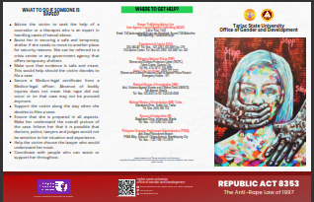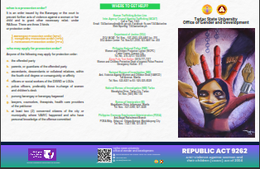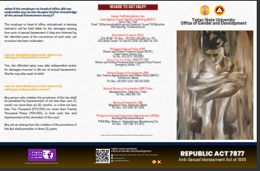

A.2 Executive, Faculty and Personnel Development
– Executive Development

“RGADC III Training titled “DigitALL: Innovation and Technology for Gender Equality””

As part of the 2023 National Women’s Month Celebration, the Regional Gender and Development Committee (RGADC) III with the Tarlac State University held a webinar titled the “DigitALL: Digital Innovation for Women Advancement”, in support with the PCW 2023-2028 theme “WE for gender equality and inclusive society”. The theme aims for “deep economic and social transformation to reinvigorate job creation and accelerate poverty reduction by steering the economy back on a high-growth path.” This highlights that growth must be inclusive, building an environment that provides equal opportunities to all Filipinos and equipping them with skills to participate fully in an innovative and globally competitive economy. The webinar is directed with a notable resource speaker and empowered woman from the Layertech Software Labs, Inc., Ms. Freigh Sangil who shared her expertise and experience in Data Science and ICT to Advance Inclusion.

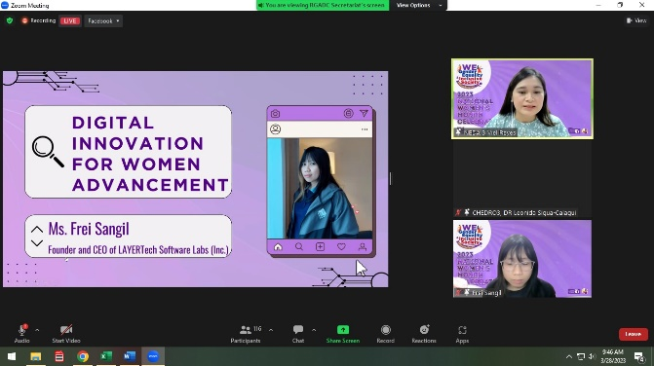
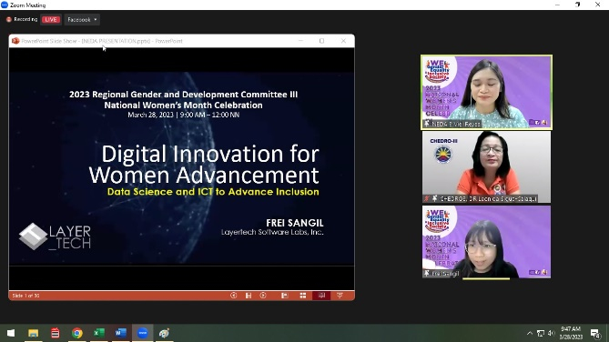

GAD-HRDMO Partnership in the “Gender Sensitivity Orientation for Newly-hired Employees”

A Gender Sensitivity Orientation for newly-hired employees of the institution took place on January 18, 2023 via Zoom, in keeping with the TSU - Gender and Development Office's goal of promoting gender-consciousness-raising, advocacy and affirmative action, and information dissemination. The purposeful event was organized and led by the Gender and Development Office in collaboration with the Human Resource Development and Management Office.
The webinar was divided into two sessions: morning and afternoon. Prof. Sheila Jane Gonzales (AM Session) and Mr. Bryan Jan S. Dizon (PM Session) led the discourse during the GSO proper. During the discussion, the differences between sex and gender were reiterated and social structures and social institutions were also explored.
Various audio and visual presentations were used to better delve into the concepts relating to gender sensitivity. Gender stereotypes were also debunked and ways to be more gender-sensitive and inclusive were cited.
The orientation webinar is one of the continuous efforts in the University in promoting gender equality and empowering the community to gain enough knowledge on gender sensitivity.
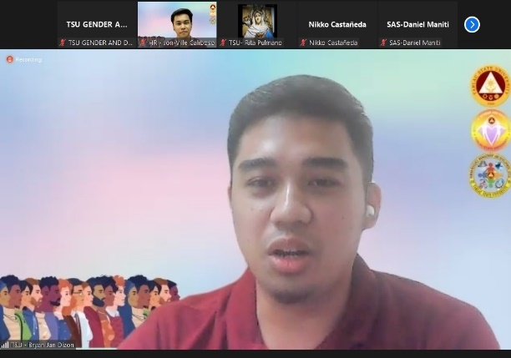
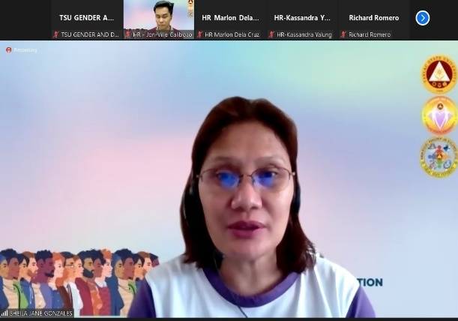

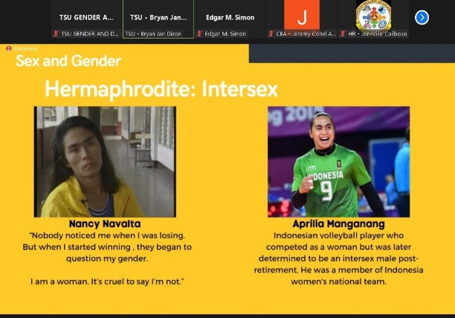
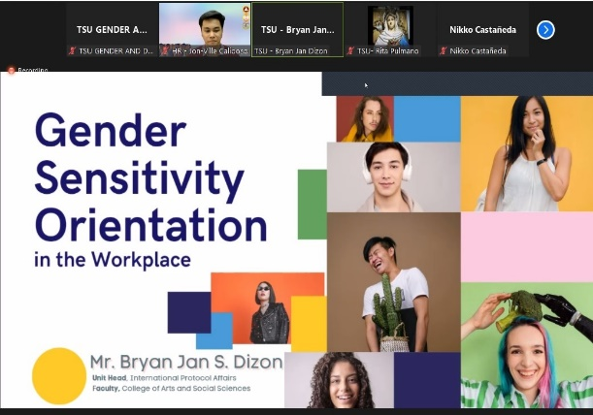

“Juana Talks” and “Lakad, Juana”

The TSU – CASS – Student Council in partnership with the TSU – Office of Gender and Development conducted and facilitated the culminating activities for the National Women’s Month Celebration 2023 on March 31, 2023 at the Smith Hall – Theater Room for the Juana Talks and at the TSU – Main Campus for the Lakad, Juana. The activities intend to emphasize and remind the society of the adversities faced and concurred by women throughout the years and up to this day.
TSU-GAD invited Ms. Carisa Balilia, JD., currently a technical assistant at the TSU – School of Law. During the discussion of Ms. Balilia, she explained and elaborated the different aspects as to which women have encountered adversities in terms of social, economic, political, and personal level. She added the legal features in relation to the topic to further educate and legally equip the participants. Ms. Kyla Marie Subron, a student from the college delivered a wonderful performance as she gave a short description explaining her performance in relation to the theme of the event. Following her performance, the question-and-answer segment proceeded where the students exhibit curiosity and interest which manifested as sensible question that are in line with the subject matter.
Through the words of the CASS - SC Adviser, Dr. Grace Anne Canlas-Hasegawa, the organizers were able to express their gratitude to the attendees 76 attendees, 12 males and 64 females, and the partnered organizations, who attended the event conducted by the CASS – Student Council and the TSU – Office of Gender and Development.

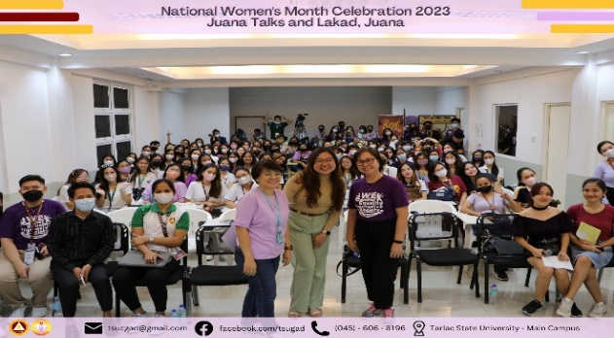
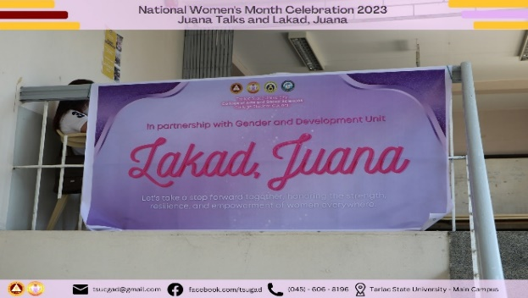

GMMS Training 2023

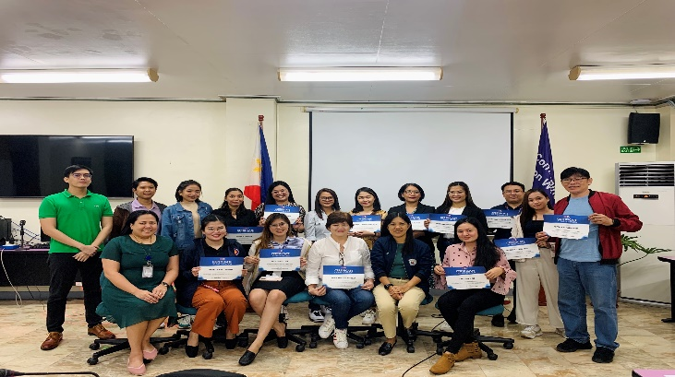
On September 07, 2023, Ms. Christina C. Ibe, and Ms. Anna Lorraine P. Capinpin, 2 technical staff of Office of Gender and Development attended GMMS Training at PCW Conference Room, Malacañang Palace Complex, San Miguel, Manila at 08:00AM to 05:00 PM.

OGAD Strategic Planning 2023

TSU - Office of Gender and Development had a Strategic Planning on November 09-10, 2023 at Baguio City with the theme “TSU Goal-oriented, Agenda-packed, Development-driven (GAD) 2023”. The two-day activity commenced with the overview of Strategic Planning under the leadership of Dr. Rita e. Pulmano, OGAD Director. In the afternoon, Childcare Unit Head Prof. Jovy P. Tomas presented the Strategic Plans of Childcare Unit, while Prof. Christine Janelle M. Santiago, Unit Head of Capacity Building presented the Strategic Plans of Capacity Building and Extension Services Unit. Afterward, Ms. Christina C. Ibe, GAD Technical Staff discussed the Strategic Plans of Database and Monitoring Unit. This strategic planning activity was attended by the GAD Coordinators, OGAD Staff, and GAD Unit Heads.

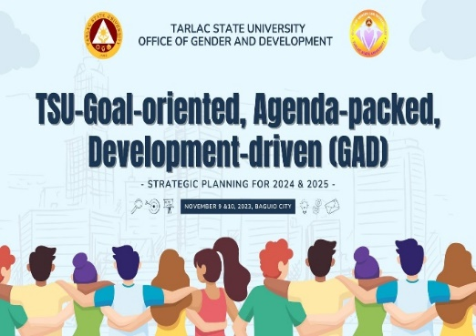
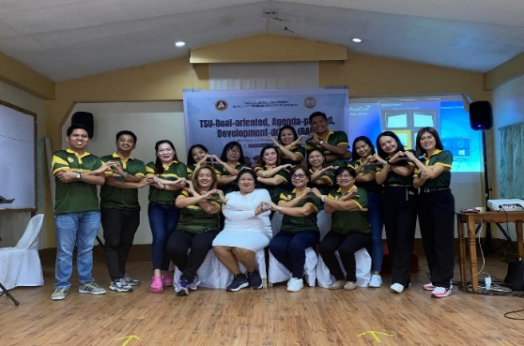
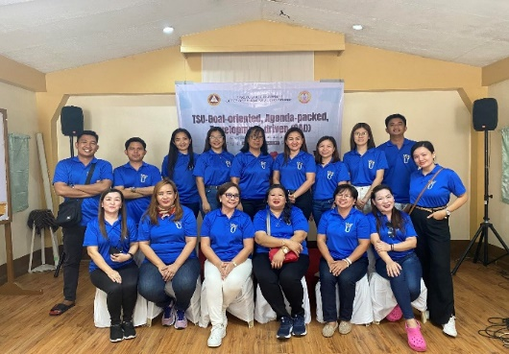

Childcare Unit Celebrates the National Children’s Month

On November 23, 2024, the Childcare Unit Celebrates the National Children’s Month with the theme “ Building Pathways of Healthy Foundation for every Filipino Child and Family” held at TSU AVR Business Center and invited a notable Resource speaker, Dr. Grace Anne Canlas-Hasegawa, an Associate Professor at the Tarlac State University, a motivational speaker and proud member of the Philippine Association of Professional Speakers for youth and is an advocate of positivity, mental health, faith, and strengthening the family. She highlights the importance of good parenting and imparts a valuable noted such as “Treat yourself”, “Have time with your spouse without the children” and “Your children is your mirror”.
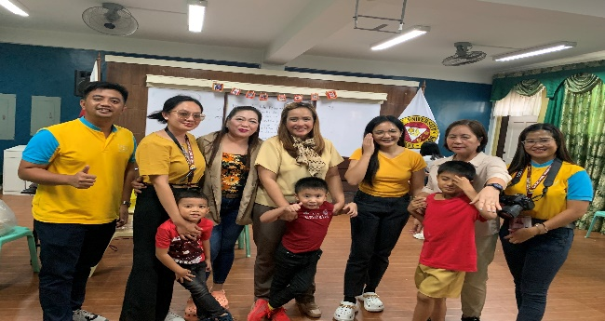
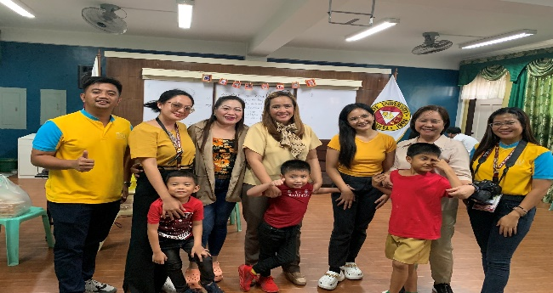

Roadmap B – Instructional Quality and Relevance Development Plan
Student Support Services Development

“Work Ethics and Safe Spaces Act Webinar”

The Career Education and Job Placement Services (CEJPS) Unit in partnership with the TSU – Gender and Development Office conducted and facilitated the webinar series on “Work Ethics and Safe Spaces Act (WESSA)” intended for the College of Business and Accountancy student interns of the university. This activity is in compliance with the CMO No. 104 s. 2017 of the Revised Guidelines for Student Internship Program in the Philippines (SIPP) for all programs for all programs and the University’s On-The-Job Training Manual (TSU-VPA-01-02) or the guidelines for the implementation of Flexible Industry Immersion program.
The WESSA was held on January 13, 2023, Monday via ZOOM. CEJPS and TSU-GAD invited Ms. Czarina C. Custodio, Chief of Student Welfare Unit of the Tarlac Agricultural University, as the resource speaker for Work Ethics, while Atty. Jansen San Juan, a licensed lawyer and the Executive Assistant to the President of University of Rizal System, was invited to discuss Safe Spaces Act.
Atty. San Juan started the discussion proper on Safe Spaces Act by comparing R.A. 11313 and R.A. 7877 (Anti-Sexual Harassment Act). He, then, presented the acts constitutive of gender-based streets and public spaces sexual harassment. He also suggested useful measures on how to prevent the occurrence of gender-based sexual harassment (GBSH), such as installation of readable warning signs against GBSH in establishments and designation of at least one (1) anti-sexual harassment officer to receive GBSH complaints. He concluded the session by discussing the penalties of employers who fail to implement their duties in preventing GBSH in the workplace.
Meanwhile, Ms. Custodio commenced her presentation on Work Ethics by defining “ethics” and by explaining the importance of having work ethics. Characteristics of work ethics were also extensively discussed. Lastly, the speaker emphasized the importance of having a life balance by setting boundaries and priorities. Overall, the webinar was attended by CBA incoming student interns accumulating a total of 454 (346 female and 108 male) participants.
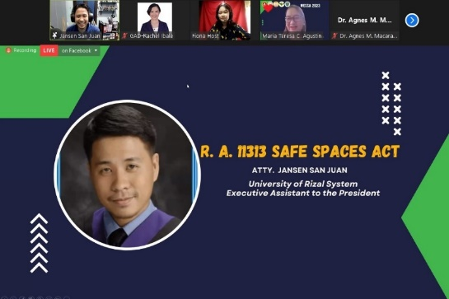
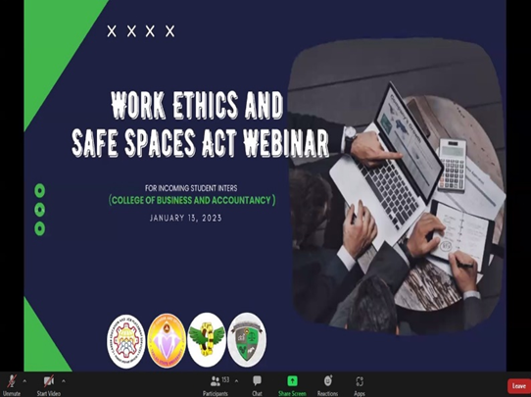

“Living with ADHD” webinar

The TSU – College of Teacher Education- Guild of Elementary Mentors in partnership with the Gender and Development Office conducted a webinar titled “Living with ADHD” on February 20, 2023 via MS Teams. This activity aimed to shed light on the conditions of attention deficit hyperactivity disorder learners and to unleash the creativity of future teachers in preparing practical strategies to enhance their students’ social skills and in identifying gender issues among boys and girls. This webinar also intends to guide the participants in creating an intervention crisis plan to deal with out-of-control emotions.
The GAD office Dr. Joanne Marie I. Escalona, TSU-CTED Bachelor on Early Childhood Education Chairperson, as the resource speaker for the webinar. Dr. Escalona began her discussion by thoroughly explaining the definition of “Attention Deficit Hyperactivity Disorder”. She also presented the characteristics and current statistics of ADHD sufferers. Moreover, Dr. Escalona clarified that the causes of the disorder remain unknown but research suggests that the cause lies in neurobiology or genetics, and not by will power, inadequate parenting, lack of intelligence, and child’s environment. It was also highlighted in the webinar the intervention approaches that can help ADHD sufferers such as psychotherapy, behavioral therapy, support groups, and social skills training. Overall, the webinar was attended by a total of 292 participants.
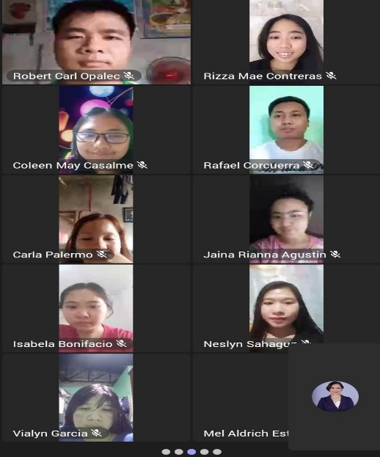

“Child Protection & Safe Spaces Act Webinar”

The College of Teacher Education – Student-Teachers Organization in partnership with the TSU - Gender and Development conducted and facilitated a webinar on child protection and safe spaces act via Microsoft Teams on February 27, 2023. The activity aims to give young women and men, specifically future educators, further knowledge regarding the legal aspects related to safe spaces and child protection. The knowledge and information that the future educators will gain from this activity would be beneficial to their future students and the community. TSU-GAD invited Attorney Jewel O. Dela Cruz, currently an Instructor at TSU – School of Law. Atty. Dela Cruz first defined they key terms regarding the topics and the legal aspects. Some of the other vital points discussed are the laws protecting children and minors, the boundaries of safe space, the situations that equates or mat lead to violation of safe space and child protection, the possible course of action when dealing with such case, and the legal consequences of violating these laws. Atty. Dela Cruz also mentioned real life scenarios to better explain situations and the magnitude of the possible violations to a child, institution, and the community. The activity was attended by a total of 830 (Male: 268; Female 562) participants. Moreover, the TSU-GAD and SSC officers facilitated the activity.
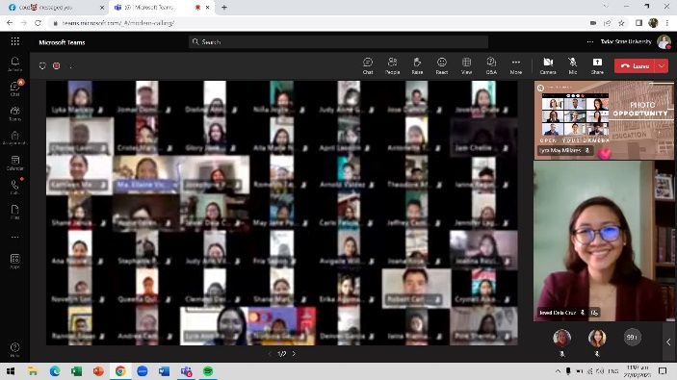
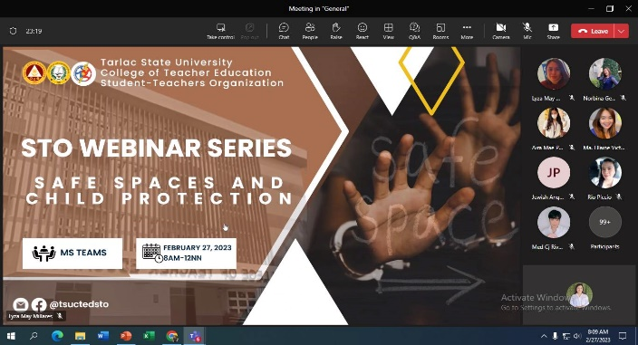

“Bend the Curve: Empowering through HIV Awareness”

The Tarlac State University – Gender and Development Office in collaboration with the College of Science Red Cross Youth Council and College of Science Student Council will be conducting a virtual activity titled “Health Awareness Webinar focusing on Human Immunodeficiency Virus (HIV)” for bonafide students, teaching staff, and non-teaching personnel on March 13, 2023, 8:00 AM to 12:00 NN via Zoom. This activity is in line with the celebration of National Women’s Month and aims to raise awareness, fight the stigma, promote responsible sexual practices in a safe space and clear out common misconceptions with the condition.
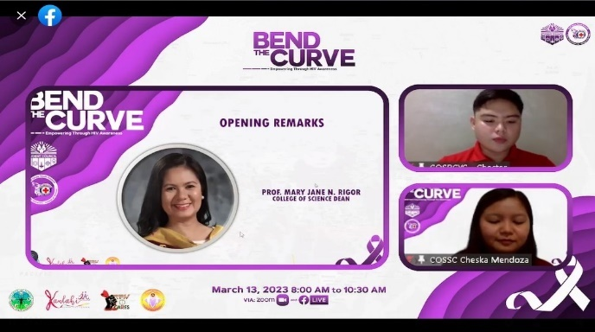
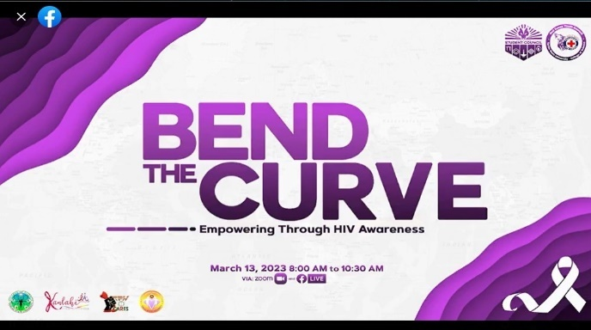

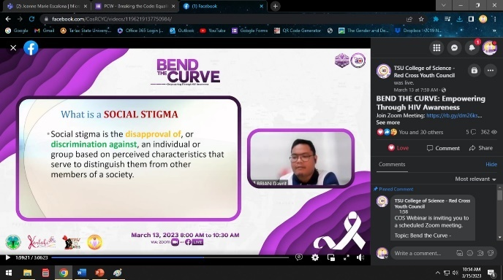
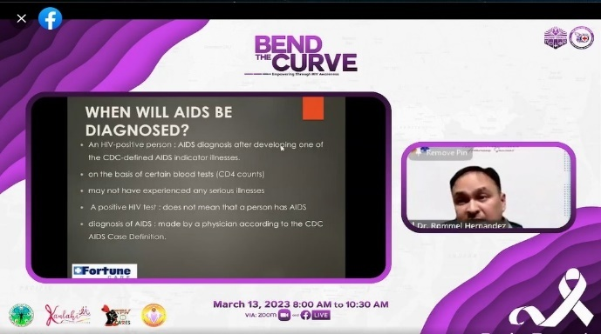

Mx. Warrior 2023

The Supreme Student Council in partnership with the TSU – Gender and Development Office conducted and facilitated the third search for the next “Mx. Warrior” of TSU which was held last March 17, 2023 at the TSU Gymnasium. This activity is an annual pageant representing LGBTQIA++ community to strengthen the university’s advocacy in promoting gender equality and eco-friendly society. The newly crowned Mx. Warrior 2023 is Ms. Jazz Rodriguez from CASS. Mx. Air, Ashlynn Manio (CASS), Mx. Fire, jhersie Tablano (CCS), Mx. Water, Eric Soriano (CBA), Mx. Land, Kim Louis Galvan (CAFA) were among other titles crowned in the said event. Meanwhile, various judges from different profession helped the organizers to choose among the candidates be crowned as Mx. Warrior.

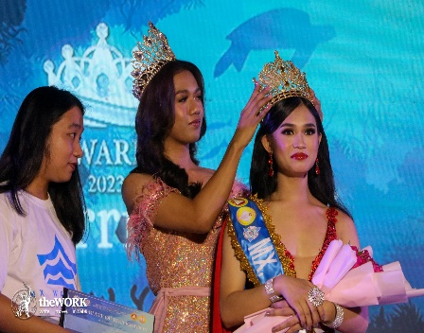
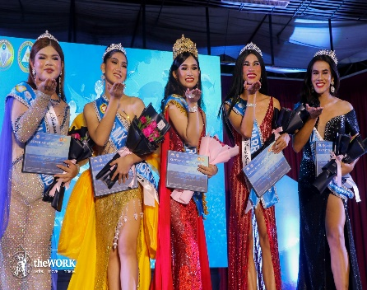

“Gender-Responsive Literacy Training Services Seminar Series”

The National Service Training Program Office in partnership with the TSU – Office of Gender and Development conducted an activity entitled “Gender -Responsive Literacy Training Service Seminar Series ” on April 29, 2023 at the Alumni Center. This activity aims to further the knowledge of the students in regards of teenage pregnancy, pre-marital and marital sex, and HIV awareness. The TSU-GAD has invited Prof. Mary Jane Rigor. Ms. Regie Jimenez and Mr. Leslie Querimit.
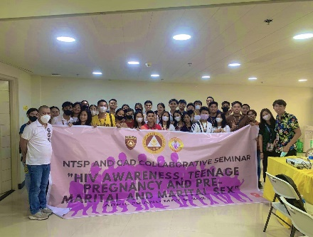
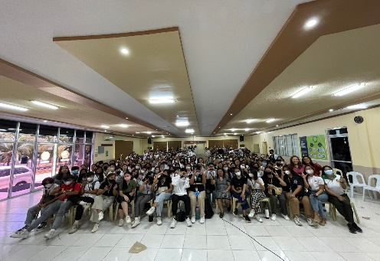

“Work Ethics and Safe Spaces Act (WESSA) Seminar”
The TSU – Career Education and Job Placement Services in partnership with the TSU – Office of Gender and Development conducted a seminar titled “Work Ethics and Safe Spaces Act (WESSA) for Bachelor of Technical-Vocational Teacher Education Major in Food and Service Management Student” on July 07, 2023. The said seminar aimed to educate participants about the importance of work ethics and safe spaces in various professional environments.
TSU-OGAD invited Prof. Czarina C. Aguilar, currently a Professor from Tarlac Agricultural University who shares about Work Ethics in the Workplace. The talk focused on emphasizing that work ethics are essential for maintaining a harmonious and productive work environment. Prof. Aguilar highlighted the various aspects of work ethics such as professionalism, integrity, punctuality, accountability and respect for colleagues. And Atty. Hendrix Bongalon, Attorney-at-Law, Bongalon Law Office at Angeles Pampanga who shares about Safe Spaces Act. The talk focused on the prevalence of gender-based sexual harassment in previous public spaces such as streets, schools, workplaces and transportation. He cited alarming statistics and shared real-life situations to illustrate the urgency and significance of the Safe Spaces Act. By providing concrete examples, he helped the audience understand the gravity of the issue and it’s impact on the victims.
This activity was attended by a total of 61 attendees, 22 males and 39 females.
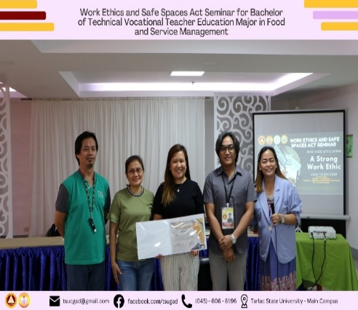
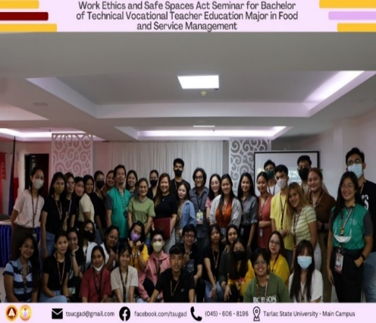
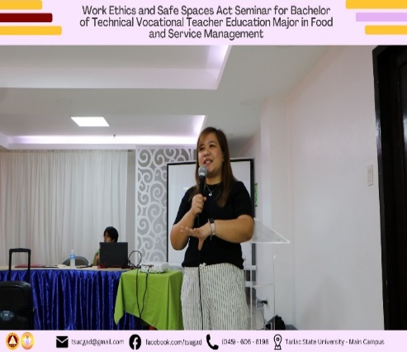

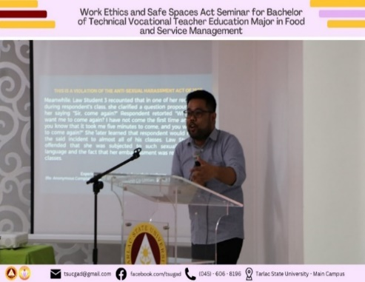
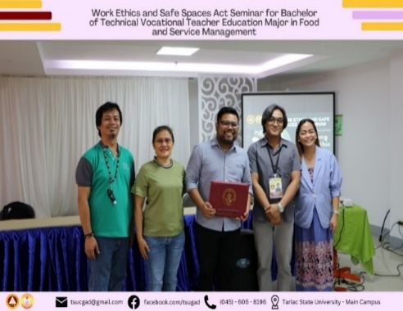
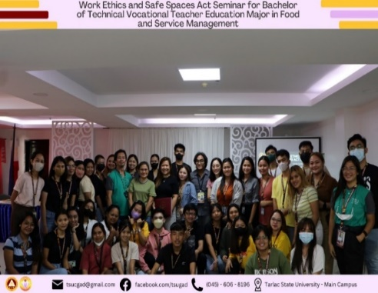

“Safe Spaces Act (Bawal Bastos Law) Seminar”

The TSU – Junior Philippine Institute Accountants in partnership with the TSU – Office of Gender and Development conducted an activity entitled “Safe Spaces Act (Anti-Bastos Law) Seminar” on September 02, 2023 at TSU-Hotel, Lucinda Campus. This activity aims to foster a socially conscious environment, securing student safety from gender-based sexual harassment in public and private workspaces, and ensuring that the studentry builds mutually supportive networks free from discrimination and maltreatment on the basis of gender identity.
TSU-GAD invited Prof. Winifredo L. Luis from the College of Arts and Social Sciences who shares about the Safe Spaces Act (Anti-Bastos Law) and its relevance for students who will undergo an on-the-job training. The talk focused on the significance of the act to the lives of the students and how it may affect the students’ prospective job experiences . Before the seminar came to an end, he emphasized the necessity of speaking up and obtaining legal protection for victims to create safer workplaces that foster gender equality.
To conclude the event, the TSU – Junior Philippine Institute of Accountants awarded a certificate of recognition to Prof. Winifredo L. Luis for his valuable insights and expertise about the topic. They express their gratitude to the attendees 336 attendees, 70 males and 266 females, and the partnered organizations, who attended the event conducted by the TSU – Junior Philippine Institute of Accountants and the TSU – Office of Gender and Development.

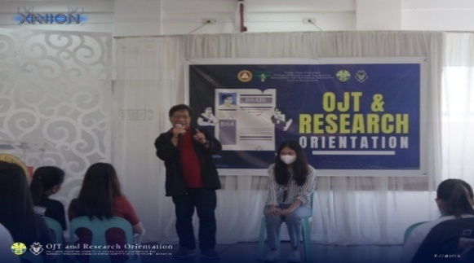
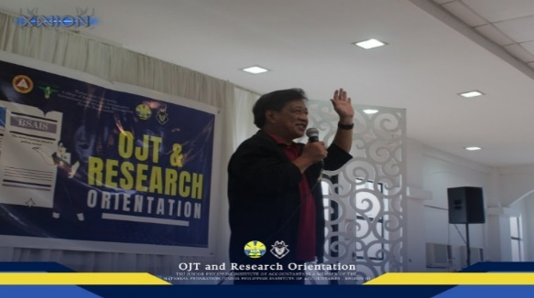

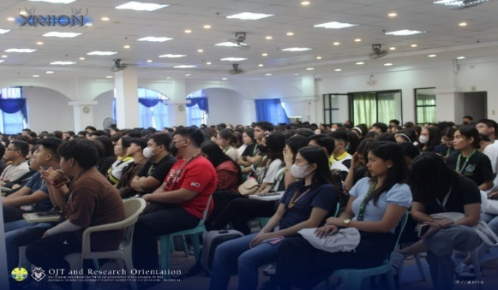

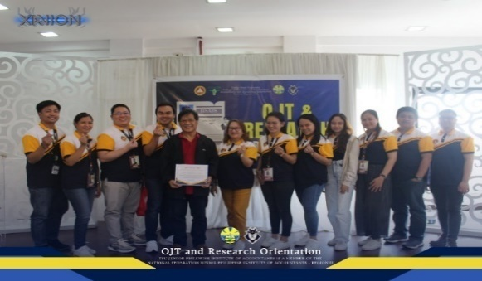

“Gender Sensitivity Orientation”
The College of Business and Accountancy – Student Council in partnership with the TSU - Gender and Development conducted and facilitated a gender sensitivity orientation via Zoom on September 16, 2023. The orientation is a regular event done with different units and colleges by the GAD to ensure the attainment of the goal of conducting trainings and seminars on gender and development in order to elevate awareness on gender concerns and issues in the TSU community. This activity aims to promotes awareness, understanding, and empathy regarding gender-related issues, fostering an inclusive and respectful environment that values diversity, equality, and the rights of all individuals.
TSU-OGAD invited Mr. Bryan Jan S. Dizon from International Affairs and Linkages Office who shares about the Gender Sensitivity Orientation. Mr. Dizon elaborated relevant salient points regarding the Mandates of a Gender Fair Society while interacting with the audience through gender inclusivity-related activities and video presentation. He also refreshed the minds of the students with an in-depth definition through a Socratic dialogue concerning the terms: Sex and Gender, along with the Social Structures and Institutions, and finally Gender Stereotypes and Social Perceptions. Before the webinar came to an end, various interesting questions takeaways were also shared and asked by the participants.

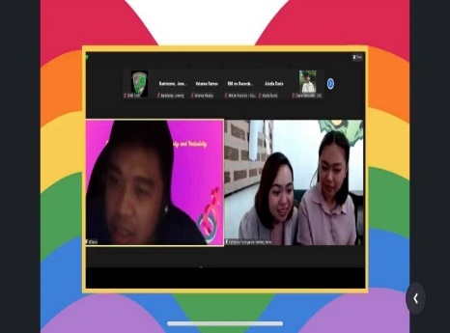
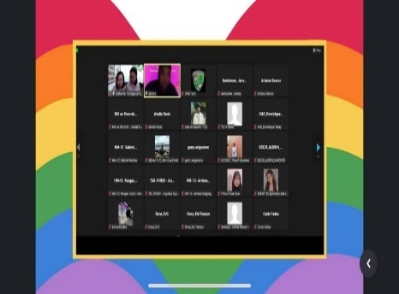
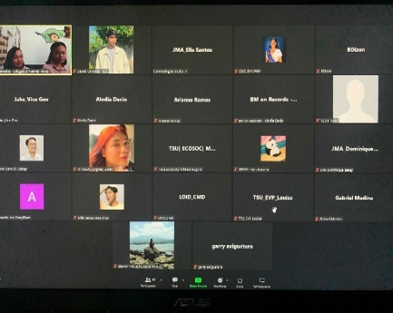

“Breaking TSUians Career Ceiling through Gender Mainstream and Labor Education Seminar”

The TSU – Career Education and Job Placement Services in partnership with the TSU – Office of Gender and Development conducted a Pre-Employment and Labor Education seminar titled “Breaking TSUian Career Ceiling through Gender Mainstream and Labor Education” for graduating students on September 18, 2023 at 09:00AM to 12:00NN at the TSU Gymnasium – TSU Main Campus. The main objective of this event is to prepare graduates for their college-to-career transition and strengthen their vision for workplace gender equality through this seminar. The TSU-OGAD has invited Ms. Carmella Canlas, Prof. Marianne Villaruel and Mr. Jumel Vitao as a resource speaker. The activity was attended by a total of 151 (Male: 74; Female 77) participants.
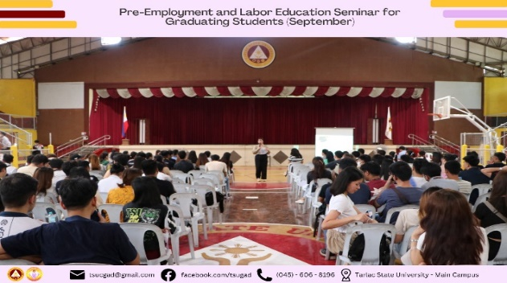
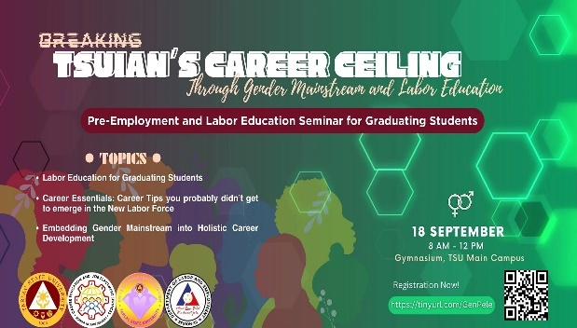

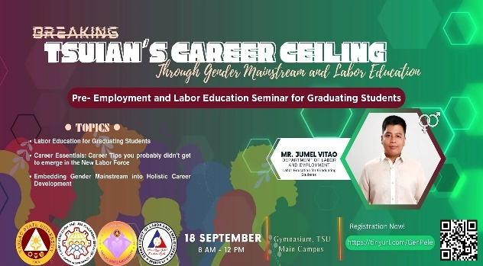
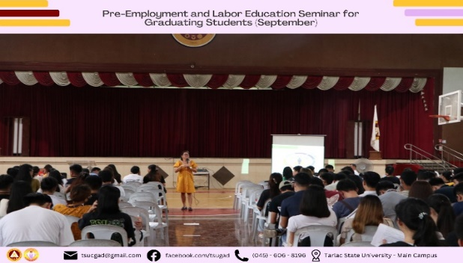

“The Power of Knowledge: Guiding Youth Towards Informed Choices in Relationships and Sexual Health Seminar”

The TSU – Federation of Red Cross Youth Council (FRCYC) COS – Red Cross Youth Council (RCYC) and The Nursing Arts Club in partnership with the TSU – Office of Gender and Development conducted a seminar titled “The Power of Knowledge: Guiding Youth towards Informed Choices in Relationships and Sexual Health” on October 18, 2023 at 08:00AM to 12:00NN at the AB Center Wing AVR – TSU Lucinda Campus. This activity aims to promote informed choices in relationships and sexual health education as this plays crucial part for fostering health and responsible behaviors. TSU-OGAD invited Mr. Elice Jude Rosete and Ms. Jazmin Joy Dizon as a resource speaker. The activity was attended by a total of 250 (Male: 86 ; Female 164) participants.
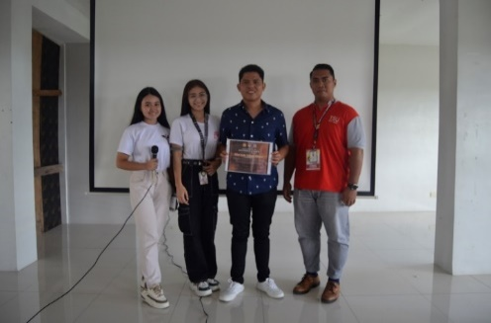
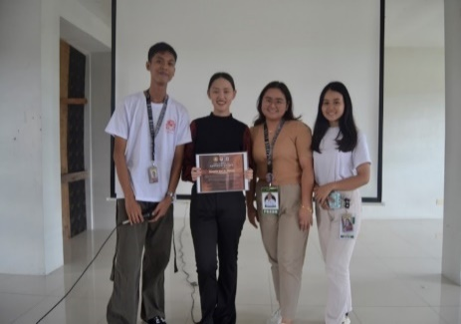
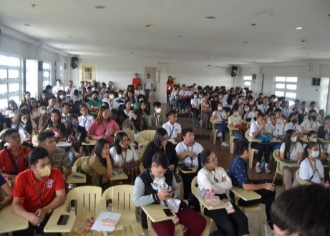

“Mindfulness Day 2023: Embracing the Present Moment”

The COESSE – The Psychological Society conducted an event titled “MINDFULNESS DAY 2023: Embracing the Present Moment” on October 26, 2023 at 08:00AM to 12:00NN at the TSY Gymnasium – TSU Main Campus. The goal of this activity is to promote mindfulness and raise awareness about its benefits, focusing on the well-being of students, specifically their mindfulness this World health Month.
TSU-OGAD invited Ms. Bai Salina Khara R. Pendatun-Ilagan currently a Yoga Teacher at Peace Love Yoga Tarlac. Ms. Ilagan utilized Patanjali’s classification of classical yoga called Ashtanga Yoga. It is a dynamic and invigorating form of Hatha yoga that demands physical and mental discipline. The event was packed with informative and engaging sessions, and the participants were able to learn new skills, gain valuable insights, and network with like-minded individuals.
To conclude the event, the COESSE – The Psychological Society awarded a certificate of recognition to Ms. Bai Salina Khara R. Pendatun-Ilagan for her valuable insights and expertise about the topic. They express their gratitude to the attendees 19 attendees, 5 males and 14 females, and the partnered organizations, who attended the event conducted by the COESSE – The Psychological Society and the TSU – Office of Gender and Development.
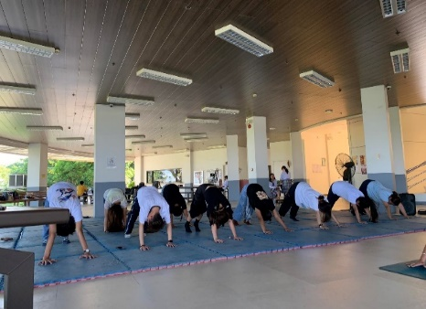
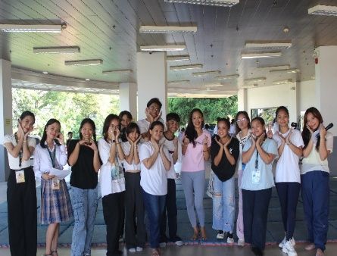
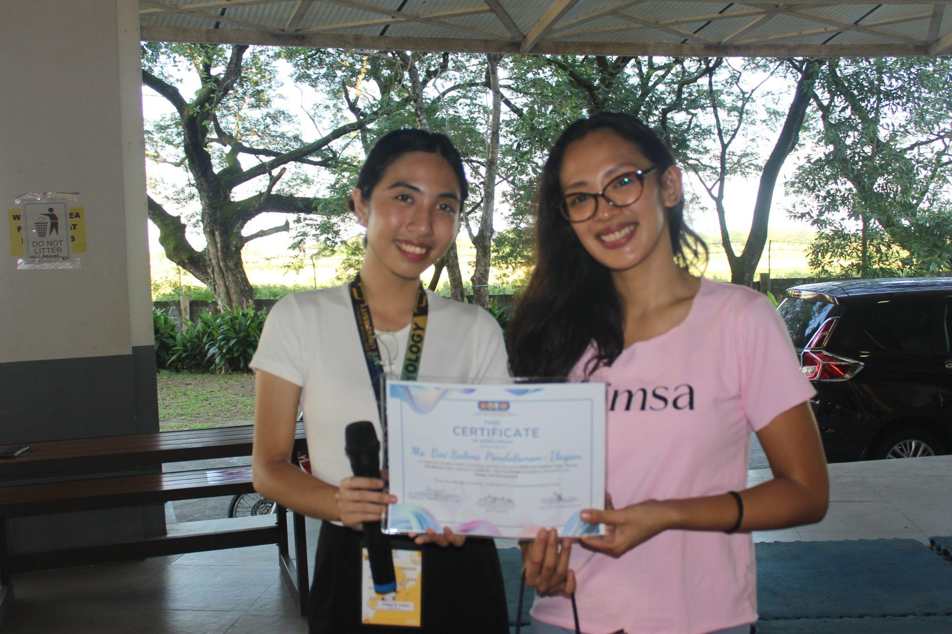

“Titindig Ako, Kasama Mo” Webinar

The “Titindig Ako, Kasama Mo” webinar conducted in collaboration with Office of Gender and Development Unit and Student Welfare Services on December 02, 2023 stands as collective endeavor to promote empowerment, inclusivity and support within our academic community. This webinar seeks to address important issues related to personal well-being, gender sensitivity, and fostering a campus environment that stands against discrimination and supports every individual’s journey. The partnership between these key units underscores the commitment to creating a campus environment that stands against discrimination and stands with every student in their journey. This webinar was attended by a total of 84 (Male: 17 ; Female: 67) participants.

“Yakap, Youre more than enough” Webinar

The TSU – Junior Financial Executives in partnership with the TSU – Guidance and Counseling Unit conducts a Mental Health Awareness webinar via Zoom and Facebook Live from 01:00PM to 04:00PM on December 02, 2023. Bearing the theme “YAKAP: You are more than enough”, the webinar aims to acknowledge and empower everyone on their journey to mental well-being through engaging conversations and inspirational talks with professional guidance from Ms. Jazmin Joy E. Dizon, MAEd, RGC, RPm. The webinar started with an opening prayer, singing of the National Anthem and TSU Hymn followed the reiteration of JFINEX Mission & Vision. Am introductory message was delivered by Prof. Christine Janelle M. Santiago, TSU-JFINEX Adviser, where she expressed her gratitude to the sponsors and different organizations that were present. Starting the session, Ms. Dizon shared “Embracing Rejections: Turning Setbacks into Opportunities” as she discussed some psychological terms. Additionally, Ms. Dizon claimed that “Diagnosis should be done by professionals”. After comprehensively answering some questions of the attendees, Ms. Dizon was given a Certificate of Appreciation by Ms. Lilyana Cunanan, Executive President of TSU-JFINEX, for being the valuable speaker of the webinar. To conclude the webinar, Ms. Cunanan delivered her closing remarks in which she leaves the quote “To all invalidated feelings – YAKAP, you are more than enough”.
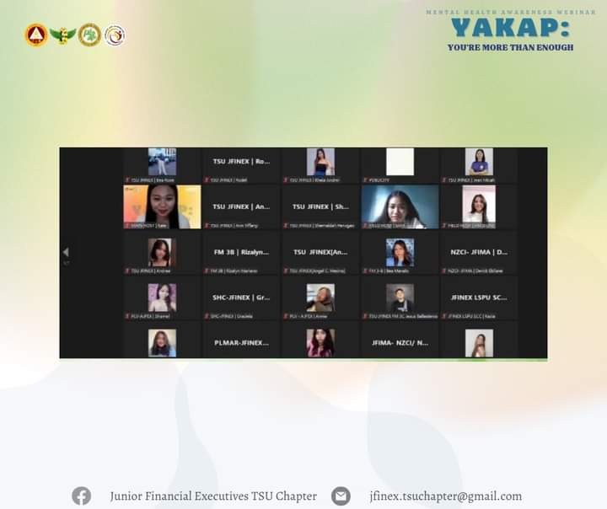
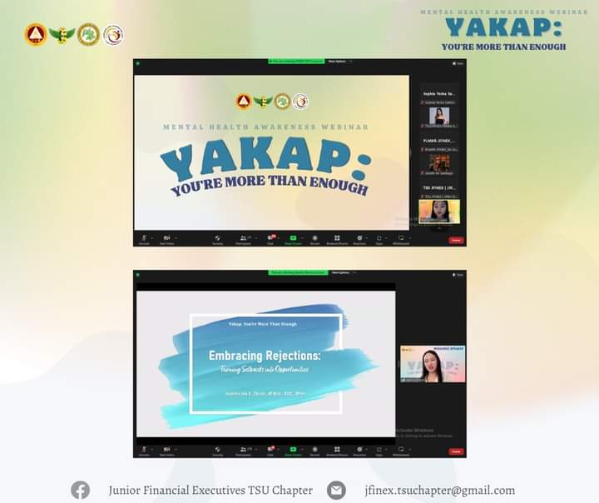

Roadmap C – Research and Community Service Development
C.2 Community Extension Services Development

“Training on the Use of Gender-Responsive LGU Ka Ba? (GeRL Ka Ba?) and HGDG Tool”

On March 3, 2023, Dr. Rita E. Pulmano and Assoc. Prof. Sheila Jane Gonzales served as resource speakers in the LGU-Gerona “Training on the Use of Gender-Responsive LGU Ka Ba? (GeRL Ka Ba?) and Harmonized Gender and Development Guidelines (HGDG) Tool” at ABC Hall, Municipal Compound, Gerona, Tarlac.
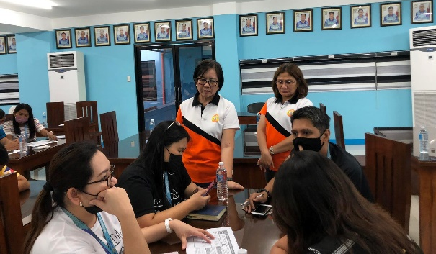
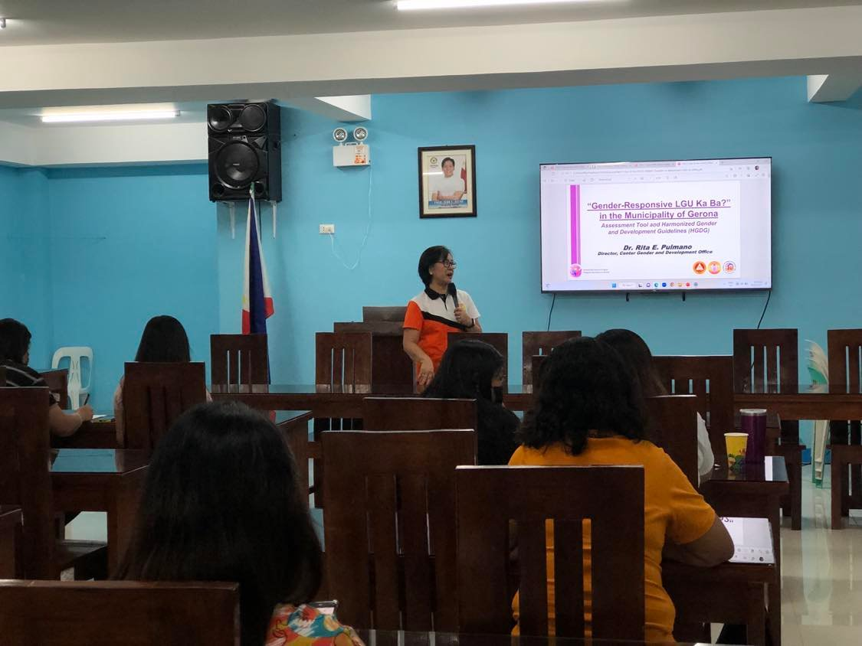

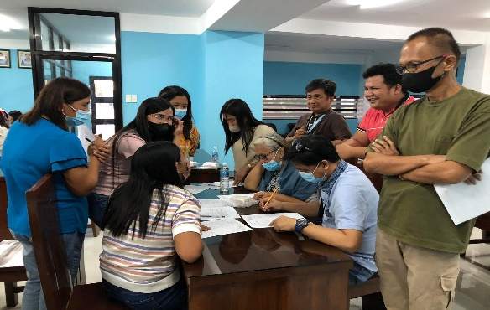
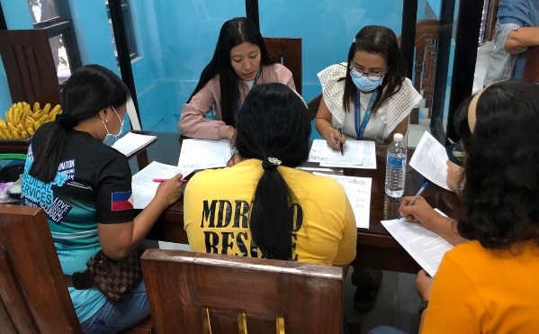

”Gender and Development Orientation for the Barangay Healthcare Workers of Capas, Tarlac”

Dr. Rita E. Pulmano served as the resource speaker in the Municipal Social Welfare and Development Office – Capas activity seminar titled “Gender and Development Orientation for the Barangay Healthcare Workers” held on June 14, 2023 at Capas, Tarlac.
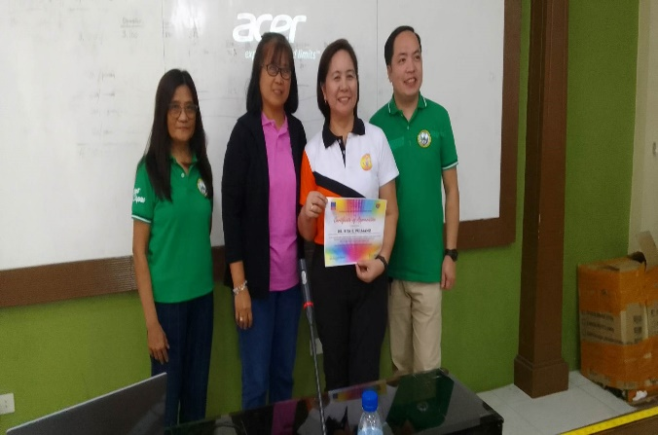
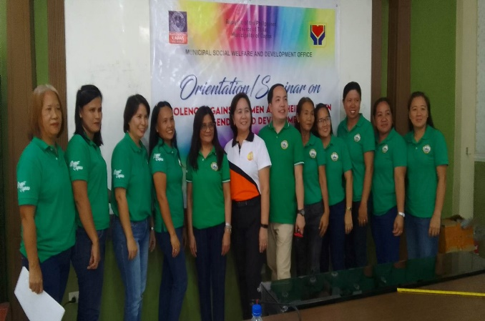

“Mainstreaming of Gender and Development Perspectives in the Development and Enhancement of Long-Term Livelihood Projects”

As part of the continuous commitment of LGU of Pura to mainstream GAD, the Tarlac State University steered a seminar entitled "Mainstreaming of Gender and Development Perspectives in the Development and Enhancement of Livelihood Projects in the Municipality of Pura" on October 17, 2023, at the Pura Event Center.
Experts from Tarlac State University-College of Business and Accountancy, comprised of Prof. Christine Janelle M. Santiago and Prof. Sheila Jane I. Gonzales, served as Resource Speakers-meanwhile, Ms. Annalyn M. Caymo, Ms. Yvette S. Legaspi, Ms. Lureza M. Pastor, and Mr. Timothy Julian Bote, served as Facilitators.
The seminar aims to integrate basic GAD concepts into livelihood planning. Gender Sensitivity Orientation was also conducted, aiming at developing a deeper understanding of the roles of women and men in society, increasing awareness of gender and development, and addressing gender-related issues in the community, particularly in long-term livelihood projects.
The activity comprises lectures, AVPS, group activities, and sharing of experiences, which overall aims to bring a better understanding of the concept of gender, how different genders have varying perspectives, the shared responsibilities of men and women, the critical need to address the gap between genders and recognize both gender's equal importance in society to promote a gender-sensitive in developing and enhancing long-term livelihood projects.
It was attended by Vice Mayor John Paul M. Balmores, Mr. Joe Myrence T. Mendoza - GAD Focal Person, and Ms. Analiza A. Campo MSWDO, and her personnel. Representatives from different livelihood organizations/associations served as participants. (Text by: MPDO Pura)
The successfully executed extension activity not only heightens awareness about gender equality issues, empowering participants to champion gender equality and foster a more equitable society, but it also reinforces the partnership between TSU and the residents of the Local Government Unit of Pura. Thus the activity is contributory to Goals 04 (Quality Education), 05( Gender Equality), and 17( Partnership for Goals) of the Sustainable Development Goals.
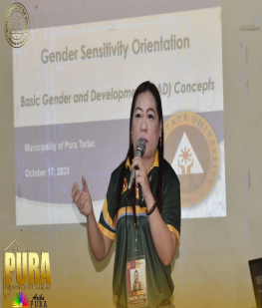

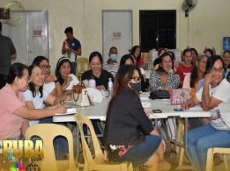
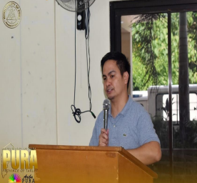

C.4 Gender and Development
Annual Campaign/Celebration

In support of the nationwide celebration, the TSU – Office of Gender and Development Office (OGAD) in coordination with various offices and units of the university, initiated the conduct of the month-long celebration of the 2023 National Women’s Month in the following activities:

2023 NATIONAL WOMEN’S MONTH CELEBRATION
MARCH 1-31, 2023

LIST OF ACTIVITIES

Activity | Tentative Date | Description | Persons/Office Involved
Printing and Posting/Display of Banner/Streamer | March 1 to 31, 2023 | Four (4) advocacy banners/ streamers will be posted in the university premises and uploaded to the TSU website and all online platforms. This is to highlight the gains achieved for women and girls, assess actions toward gender equality and look forward to steps that must be taken to ensure progress in empowering women. | GAD Staff and Coordinators  TSU-OPA
Kickoff Activity for National Women’s Month Celebration | March 7, 2023 | A university-wide hosting of the Gender and Development Office of the flag-raising ceremony in support to the NWMC. This activity is a venue to commemorate women and to celebrate Filipino women’s power to take the narrative, raise priority issues that matter to them, and call for concrete actions. | GAD Office  GAD Coordinators  Supreme Student Council
#PurpleWednesdays | March 1,8,15,22, & 29, 2023 | The TSU Community is encouraged to wear anything PURPLE on all Wednesdays of March to signify support to gender equality and women’s empowerment. | All Offices/Units and Colleges
Musika ng Kababaihan Fridays (#MNKFridays) | March 3, 10, 17, & 24, 2023 | This will highlight the advocacy of the 2023 NWMC through music. The 87.5 Firefox Radio Station will be utilized to play songs from PCW’s MusikJuana Songwriting Contests 2021 and other PCW advocacy songs which aim to share music as an advocacy tool for gender equality and women empowerment. | GAD Coordinators
#PurpleYourIcon Online Advocacy | March 1-31, 2023 | To make the advocacy take over the online realm, the TSU Community is encouraged to post about the celebration/campaign, and sharing posts from PCW’s official social media accounts regarding 2023 NWMC.  The TSU community can also use the NWMC Advocacy Profile Photo Frame and other online materials (Instagram Story/Facebook My Day Frames, and Viber Stickers). They can also showcase their activities online and join the online thread using #WEcan beEquALL. | GAD Office  GAD Coordinators

“2023 NWMC Kick-Off Activity”

TSU-GAD, headed by Dr. Rita E. Pulmano with the assistance of GAD Coordinators and GAD Staff, spearheaded the Kick-Off Program for the National Women’s Month Celebration 2023 during the flag-raising ceremony on March 7, 2023 at the TSU Main Campus. With the theme, “WE for Gender Equality and Inclusive Society”, this year’s celebration seeks to promote a society that ensures inclusion, protection of fundamental freedoms, diversity, and social justice and in which every individual, each with rights and responsibilities, is empowered and encouraged to take an active role to play. Furthermore, with the sub-theme “DigitALL: Innovation and technology for gender equality”, this year’s celebration will call for the empowerment of women and girls toward maximizing their benefit from innovation and technology and bridging the gender gap in ICT and connectivity.
After the Kick-off program, attendees were given free breakfast.

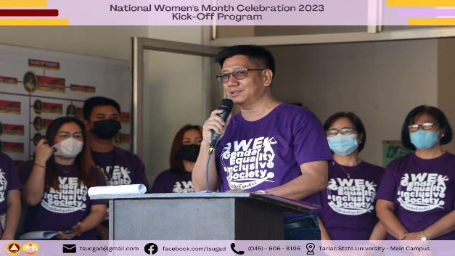
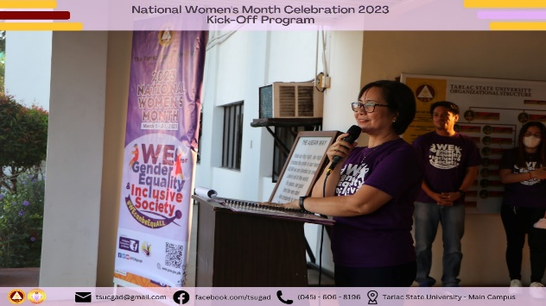

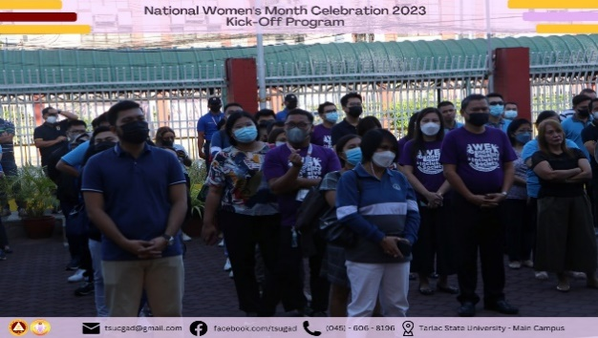
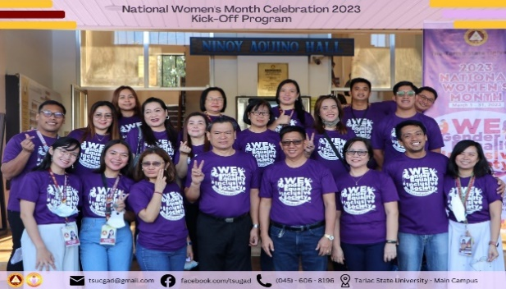

2023 18-Day Campaign to End Violence Against Women (VAW) Highlight of Activities

To continuously advocate for the prevention and elimination of VAW in the country, the Philippine Commission on Women (PCW) is calling for solidarity among every Juan and Juana as it leads the annual 18-day Campaign to End VAW with the 2022-2027 recurring campaign theme, “UNITEd for a VAW-free Philippines.”
TSU-GAD Office spearheaded the annual observation of the 18-Day Campaign to End Violence Against Women from November 25 to December 12, 2023, to support the Philippine government’s goal of protecting the human rights of women and girls by upholding its commitment to address all forms of gender-based violence and to raise awareness on the problem of violence and the elimination of all forms of violence against women and girls.

2023 18-DAY CAMPAIGN TO END VAWC
November 25-December 12, 2023

LIST OF ACTIVITIES

Activity | Schedule | Description
Program Activity for the 18-day Campaign to End Violence Against Women  *Poster Making Competition  * Spoken Poetry Competition  *Advocacy Video  *Interpretative Dance  *Filmmaking Competition  *Macho Choir Dance Challenge (Student)  *Macho Choir Dance Challenge (Employee) | December 05, 2023  07:00AM onwards  December 05, 2023 | This program will be held in support of the campaign against VAW. The rationale behind this activity is to disseminate and raise awareness against VAW within the university.  The activity envisions to wheedle not just women, children and people in the vulnerable sectors, but also men to campaign against VAW and to end the impunity, discrimination, and violence against women.
BAWAL BASTOS SEMINAR | November 30, 2023  01:00PM – 05:00PM | addresses gender-based sexual harassment in public areas such as streets, privately-owned places open to the public, and public utility vehicles, among others.
BABAE KA SEMINAR | December 01, 2023  01:00PM – 05:00PM | This activity aims to raise awareness against VAWC and to further the knowledge of students about the rights and protection of women and children through competitions which will encourage the students to express their activity and talent
Anti-Violence Against Women Campaign | December 05, 2023 | This activity aims to raise awareness against VAWC and to further the knowledge of students about the rights and protection of women and children through competitions which will encourage the students to express their creativity and talent
TITINDIG AKO, KASAMA MO SEMINAR | December 02, 2023  01:00PM – 05:00PM | This activity aims to raise awareness against VAWC and to further the knowledge of students about the rights and protection of women and children through competitions which will encourage the students to express their creativity and talent

Kick-off Activity for the 18-day Campaign to End Violence Against Women

The Tarlac State University joins the 18-Day Campaign to End Violence Against Women and Children, an annual advocacy campaign that runs from November 25 to December 12 as mandated by Proclamation 1172, s. 2006.
It aims to increase public awareness on the issue of violence against women and children, and to combat all forms of gender-based violence as enshrined in the 1987 Constitution.
This year’s campaign highlights the accomplishments and milestones made in the country’s efforts to prevent and address VAW toward the assessment and strengthening of VAW-related laws’ implementation, in consonance with the new six-year (2022-2027) recurring theme “UNiTEd for a VAW-free Philippines”.
Let us all work together to pursue our shared vision of a VAW-free community!
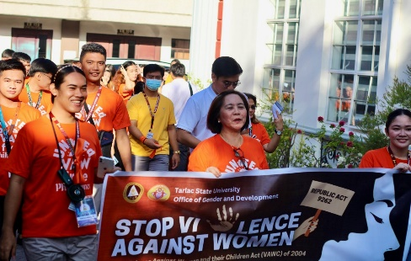
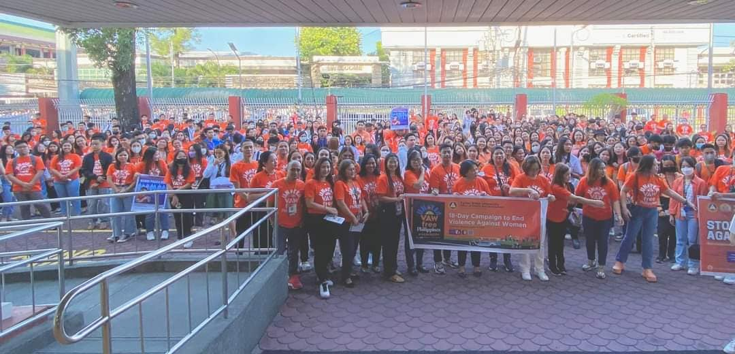
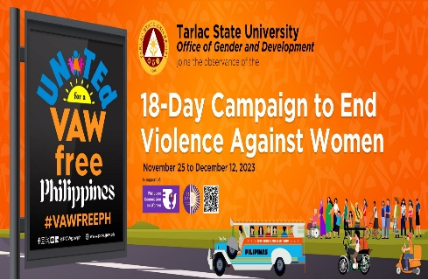

Roadmap: D – Institutional Quality Assurance Development Plan
D.3 Quality Management System Development

TSU GAD Accomplishment Report FY 2022

On February 24, 2023, the Office of Gender and Development submitted the GAD Accomplishment Report F.Y. 2022 to the Gender Mainstreaming Monitoring System of the Philippine Commission on Women. The AR has a total of 34.59% of GAD Utilization.

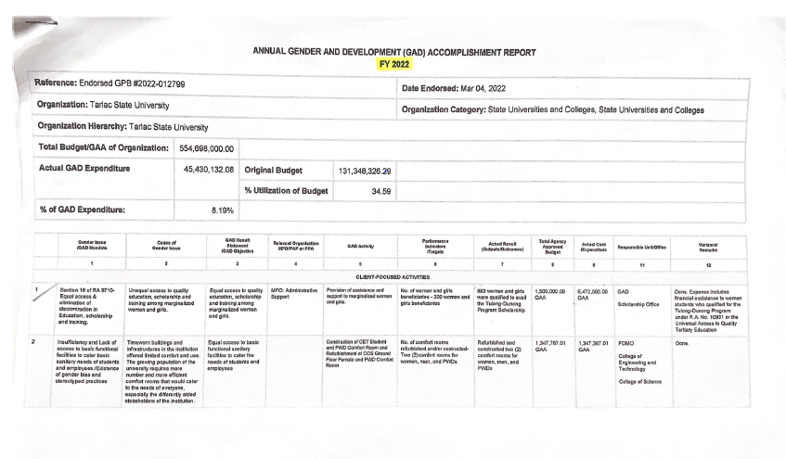

Revised TSU GAD Plan and Budget FY 2023

On January 24, 2023, the Office of Gender and Development submitted the GAD Plan and Budget F.Y. 2023 through the Gender Mainstreaming Monitoring System of the Philippine Commission on Women. The revised GPB has a total of 7.40% of GAD Allocation.

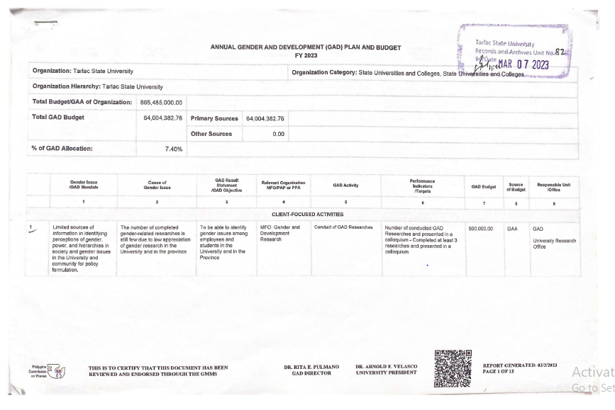

Prepared by: Attested by:
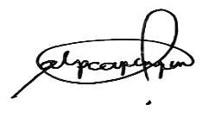

MS. ANNA LORRAINE P. CAPINPIN DR. RITA E. PULMANO
Technical Staff, Office of Gender and Development Director, Office of Gender and Development Office

